Eagles and Spears:

USA v Morocco Football 24 olympics
Written by: Charles James IV Edited By: Charles James Art By: OpenArt Starter
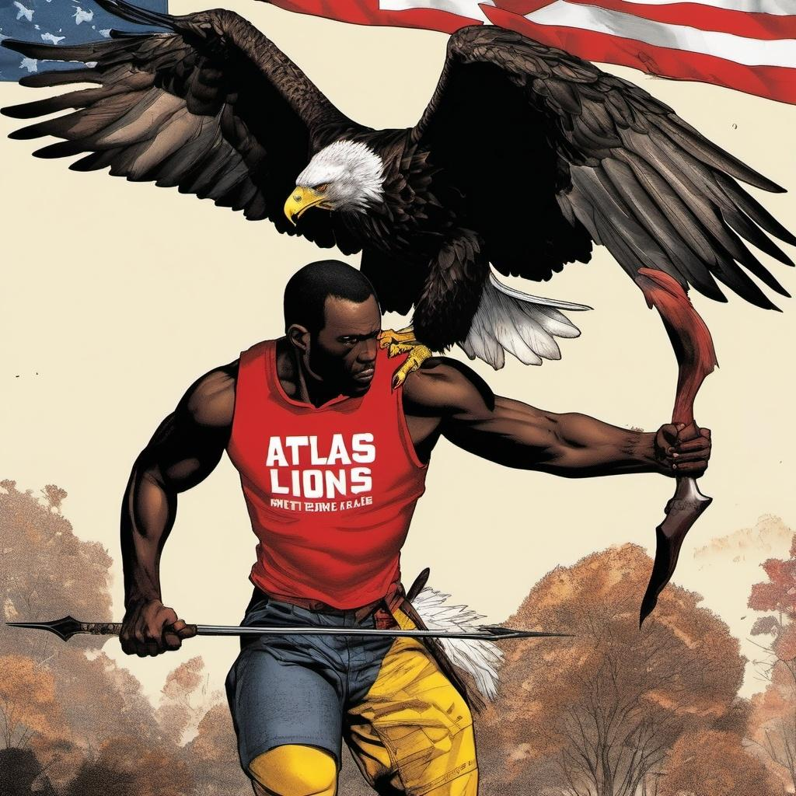

Would you hunt eagles with a spear?

This symbolized the combat between Team USA and Team Morocco, the Atlas Lions, during the 2024 Olympics U-23 Men’s Football quarter final match.

Morocco had recently become the Africa U-23 football champions. Team USA was once again the underdogs. However, with two wins under their belts, Team USA came in with hope.

Unlike the match against France, the final score of 4-0 in favor of Morocco was greater aligned to the actuality. Let us examine how this aerial combat explains the divergence between the ending and the reality of the story.
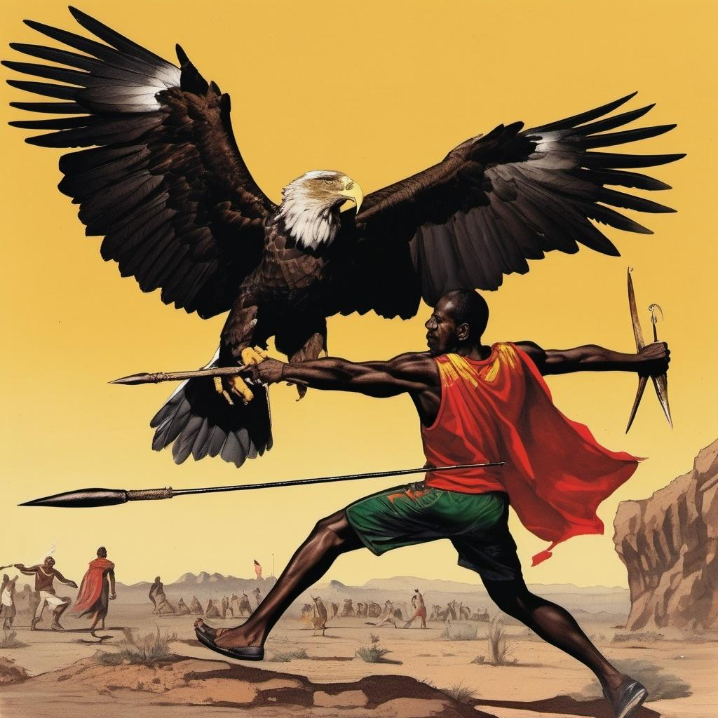
Naturally, Team USA was the eagle. The play style of expanding backwards to create spacing before swooping quickly over vast distances mimicked their hunting style.

Conversely, Morocco was like a spear. They took on a relentless and aggressive style. The team inched forward with tight short passes and acute angled attacks. They rarely would return ground taken.

As the game drew on and openings formed, Team Morocco would start to use longer and more daring thrust passes. This mirrored the prodding of a spear before taking deep lunges into weak points.

There were two determining factors in a fierce battle such as this: striking first and striking swiftly.

It was evident that the first team to deliver a decisive blow would wound the opposition and initiate an opportunity for an overwhelming onslaught. However, an oft overlooked third factor would hold heavy weight in who would strike first.

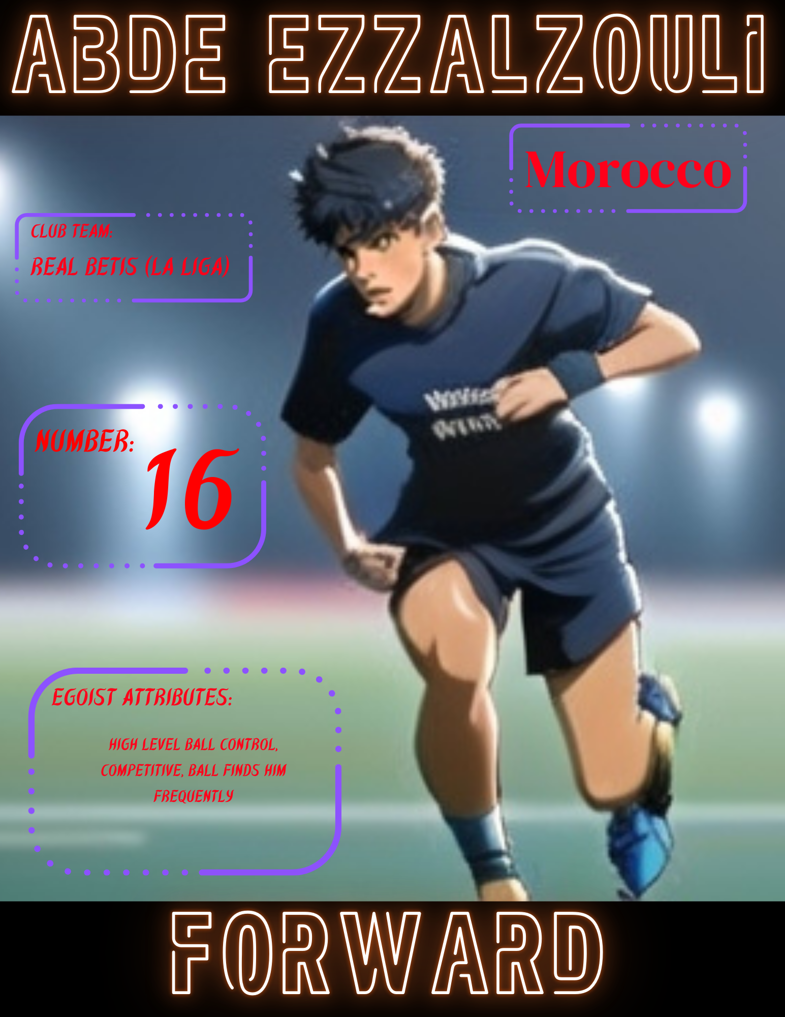

Team Morocco moved with a clear level of confidence. Each player quickly executed a few feints or dribble moves upon receiving the ball before swiftly passing at the opening of the game. The most daring was their number 16, Abde Ezzalzouli .

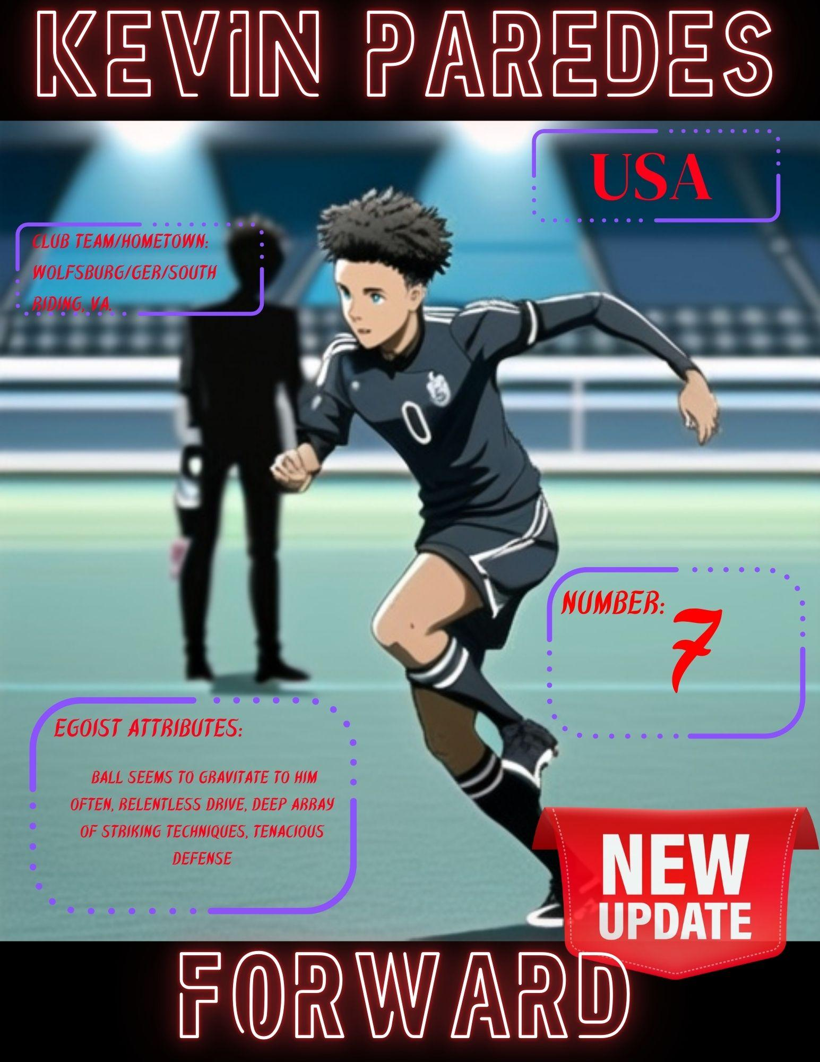

A prominent battle of the contest occurred as Team USA’s number 7, Kevin Paredes, often met Ezzalzouli at the edges of the field. These bouts were a testament to Paredes’s progression as an egoist.

Paredes had an unstoppable motor from the first kick. Paredes frequently bested Ezzalzouli on defense as he attempted to weave and maneuver past him. Paredes showed significant defensive progress as he executed many terrific tackles in the first half of play.

The continued theme of instinct held strong to the quarterfinals as the ball seemed to be a heatseeker locked on to Paredes’s feet. Team Morocco's defense followed suit.

Morocco’s play against him was notably chippy with an extensive array of no calls, including a heavy shove from their number 18, Amir Richardson, in the first 20 minutes of play. This habit of chippy play against Paredes prevailed until fairly deep into gameplay.

The third factor is underrated, but present in every battle: terrain. The terrain in this case was the referees.

Morocco showed great expertise in manipulating the use of foul calls. This resulted in a net disparity of seven foul calls in the game. 17 were against the USA and 10 against Morocco. Calls became more frequent for the USA after the score reached 3-0.

Of these 17 foul calls, the earliest were the most influential. Though calls for Paredes were few and far between, the first led to a penalty kick early on.

Paredes executed a brilliant dribble drive past three defenders. He was tripped en route to the goal which resulted in a penalty. USA’s number 14, Djordje Mihailovic, claimed this attempt softly with a light and easy kick. It was quickly scooped by Morocco's goalkeeper.

An early penalty in the 29th minute led to the first successful strike. There was seemingly little contact, similar to the aforementioned call.

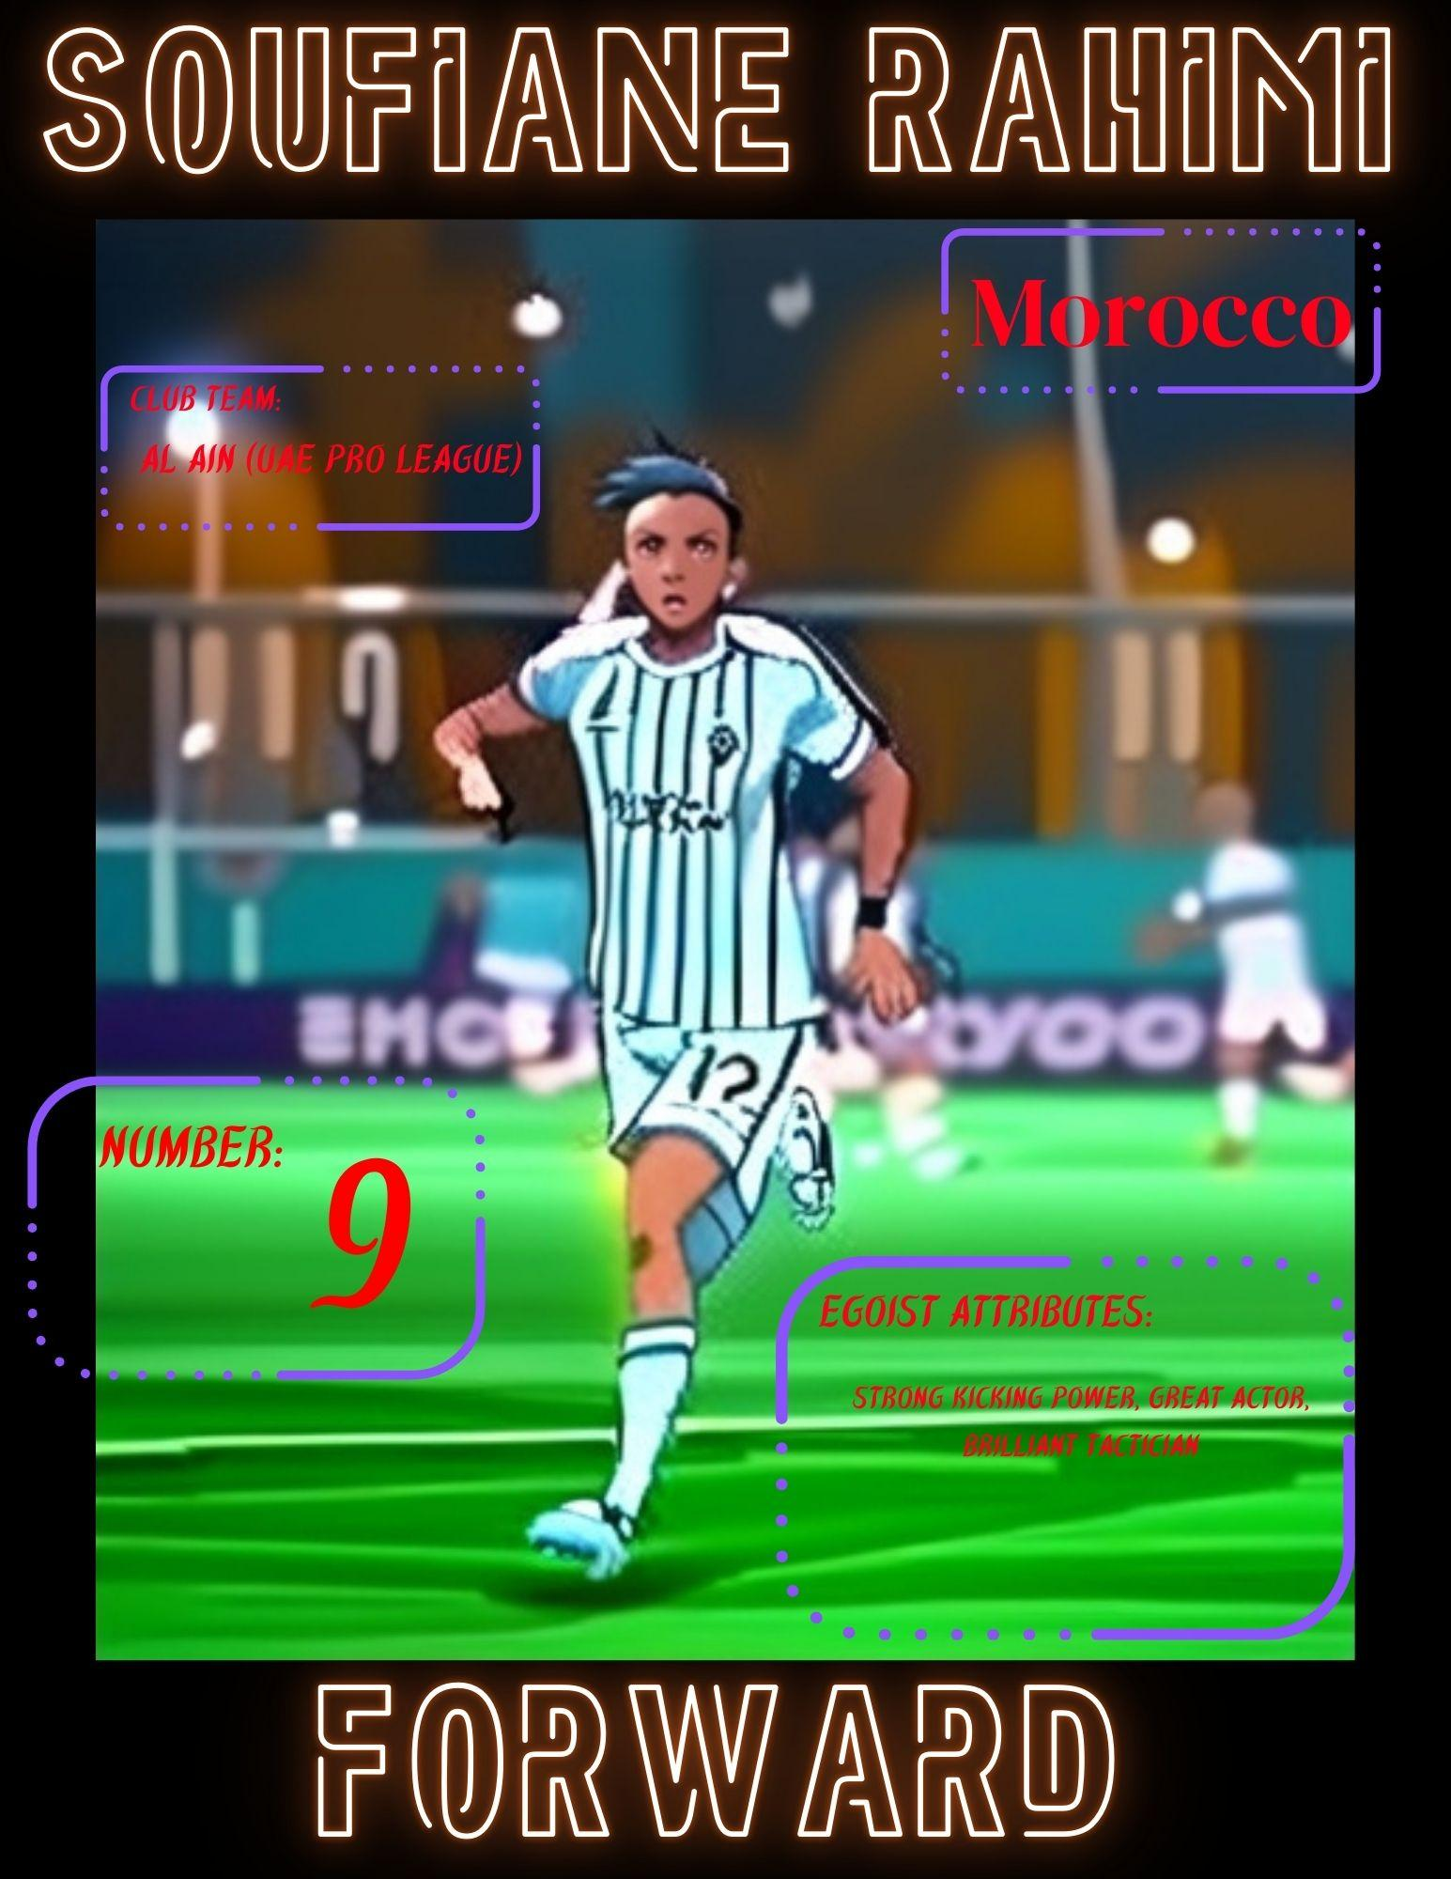

However, Team Morocco's players exhibited quite brilliant acting skills to secure calls, a trait it seemed Team USA would need to adapt. Moreover, Morocco’s number 9, Soufiane Rahimi , scored with a much more emphatic kick to the bottom left corner than was seen in the prior instance.

The atmosphere of the arena was set aflame, both literally and figuratively. Excited fans of Morocco began to light flares around the stadium. Some fans even chanted “U-S-A” satirically to other fans.

Later a message appeared on the large screen stating that flares were not allowed.

The use of flares was contained directly as well as Team USA could contain Team Morocco. More flares erupted each time the Atlas Lions scored. The air tasted of flare smoke.

Rahimi showed that it takes a crew to put on an act soon after. Following a clean tackle and steal from him by Team USA, he flopped and rolled upon the ground causing the referee to stop gameplay. He stunted momentum for a feverish push by Team USA.

The medics came and went as swiftly as Rahimi began to stand and wave them off after getting water. Water really is the greatest “cure-all.”
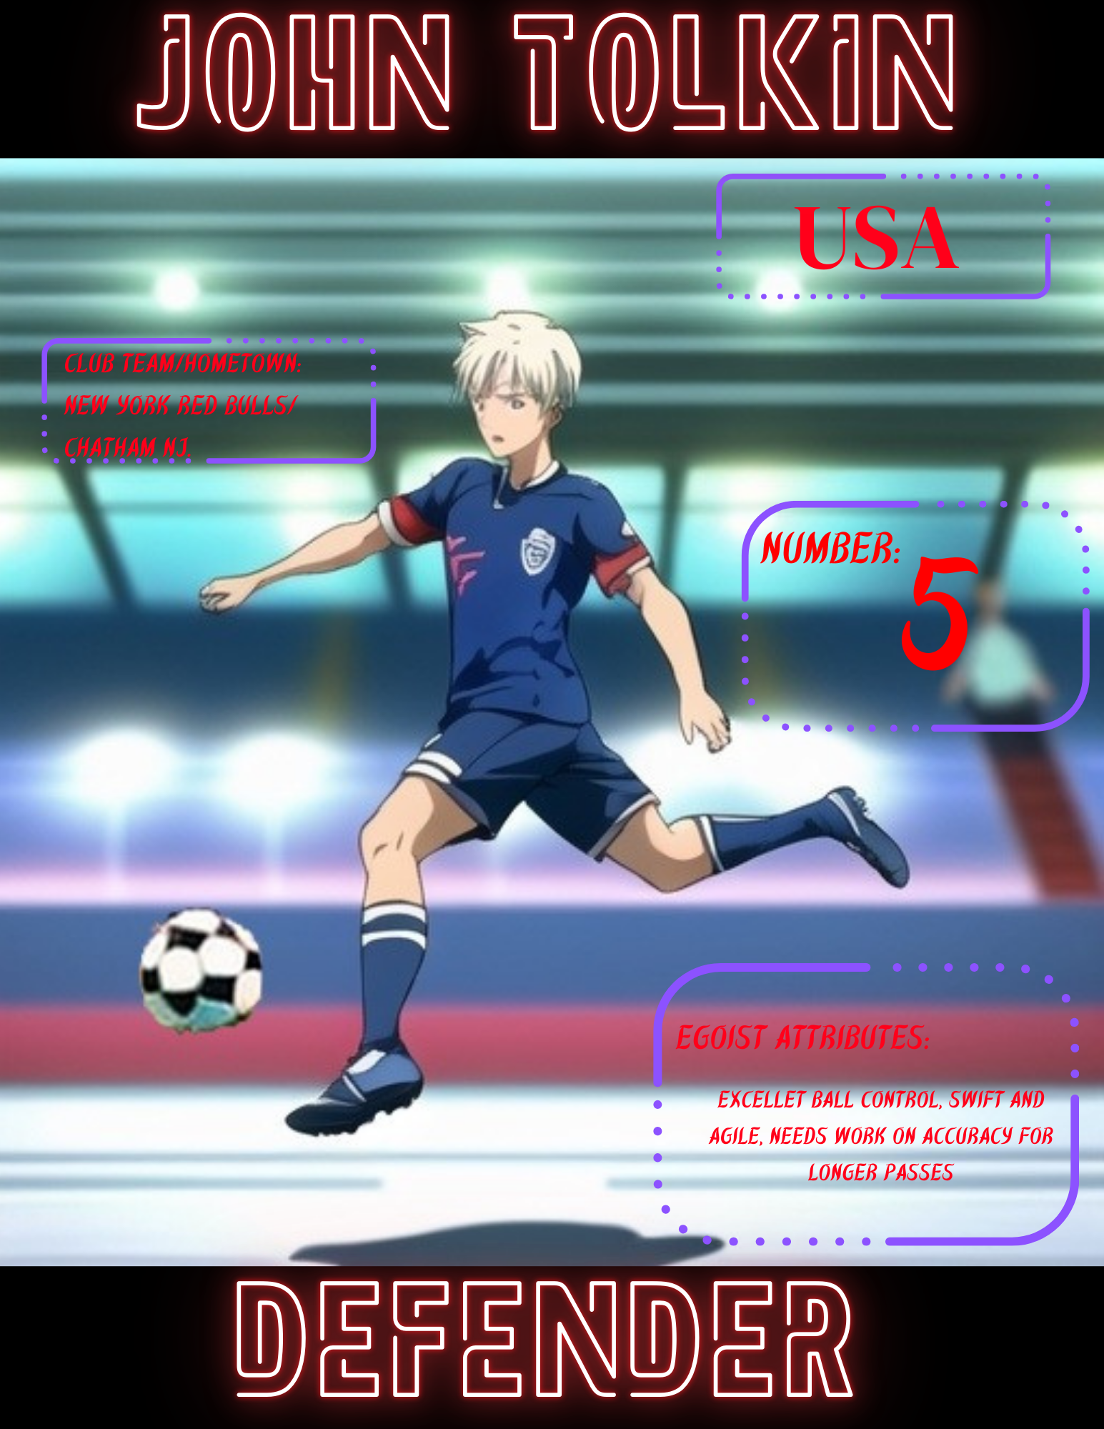
This disadvantage unearthed another gem and potential egoist of the roster. Team USA number 5, John Tolkin, exhibited stellar confidence with the ball. He often blazed by with dribbling spins and excellent speed with the ball.

This was a necessary awakening for a team in need of urgency. Surprisingly, Team USA dragged their feet for a time in attempting to even the score. This agitated Paredes, who seemed to be one of the few immediately increasing their activity.

Paredes somehow enhanced his already unnaturally high motor on both offense and defense. He chased intently after loose balls and was seen visibly calling for his teammates to do the same.

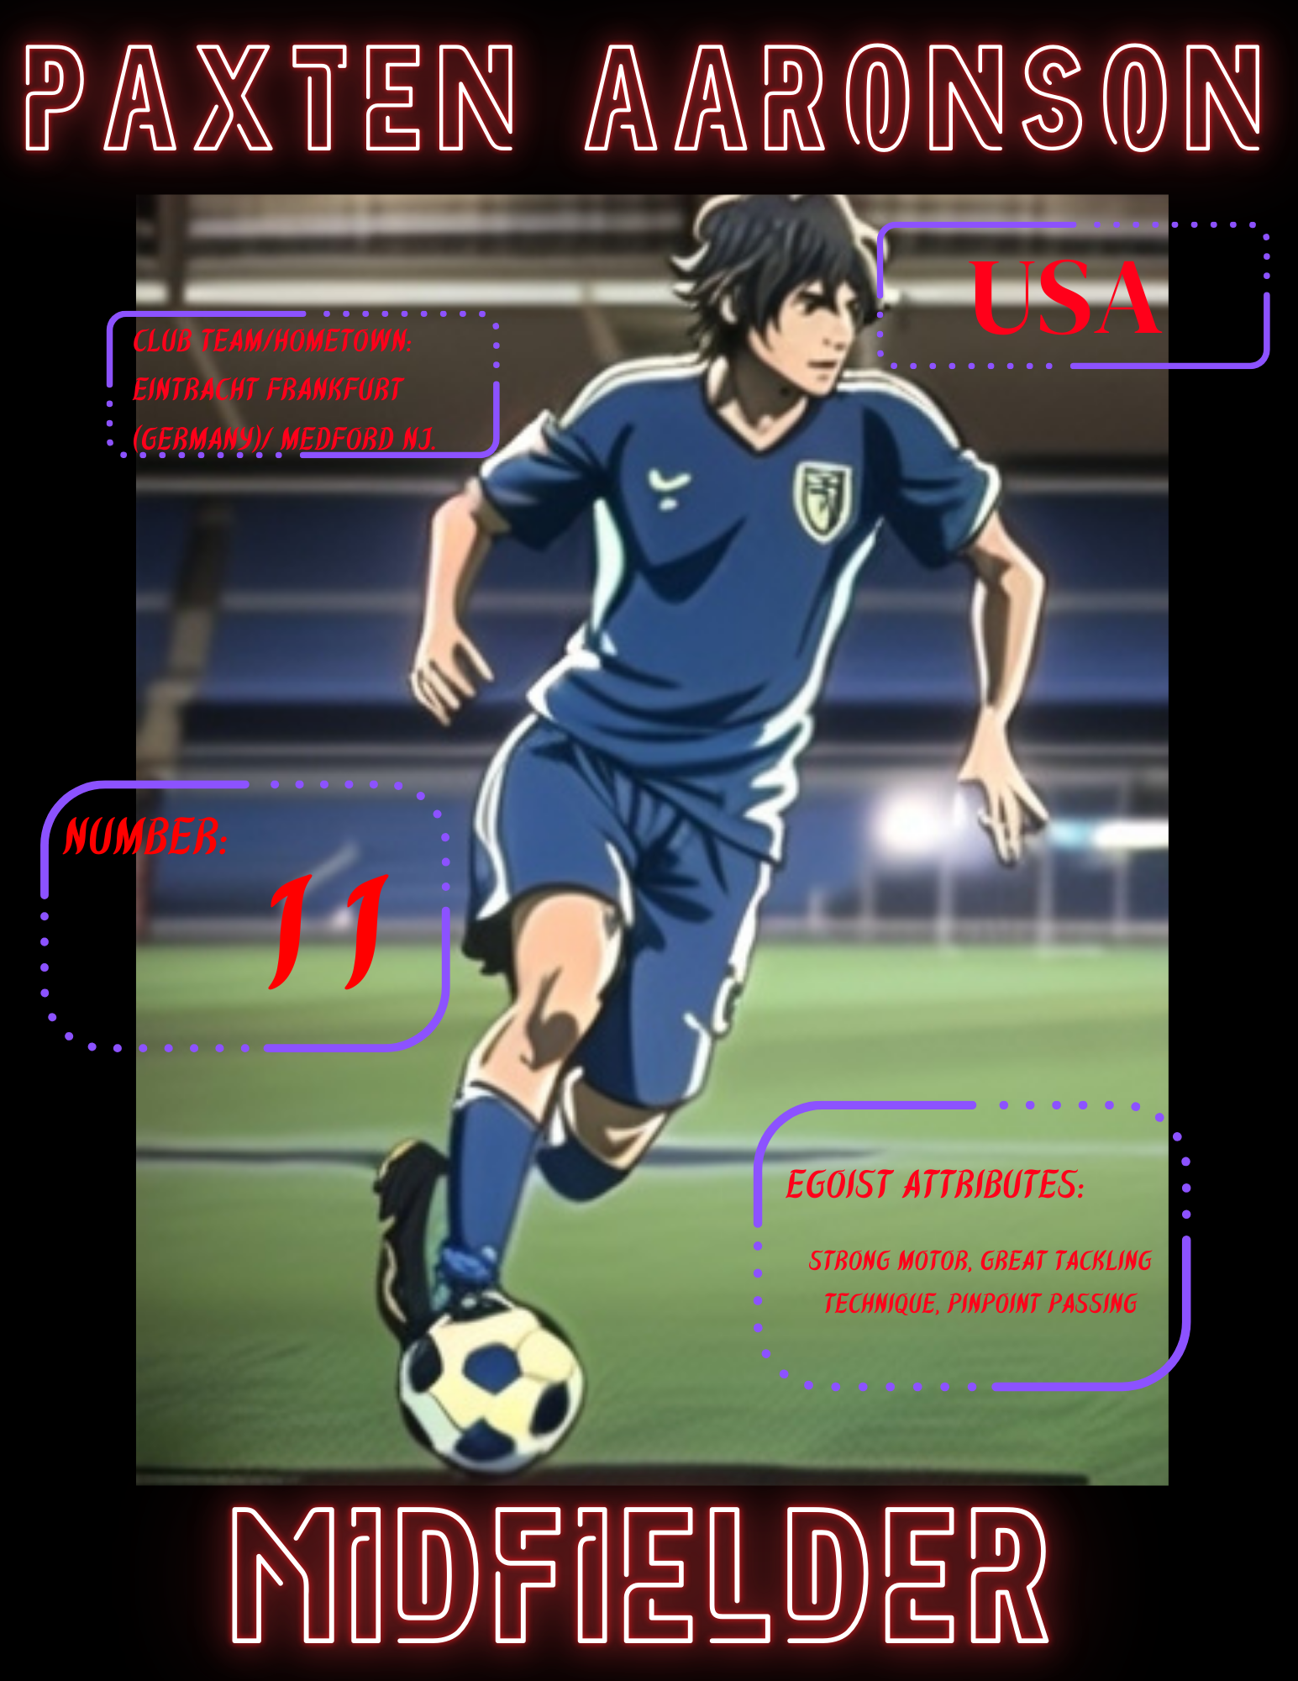

One by one Team USA members answered the call. Team USA number 11, Paxten Aaronson, and number 2, Nathan Harriel, began to level up the defensive pressure. Aaronson in particular showed great tenacity during the second half of the game.

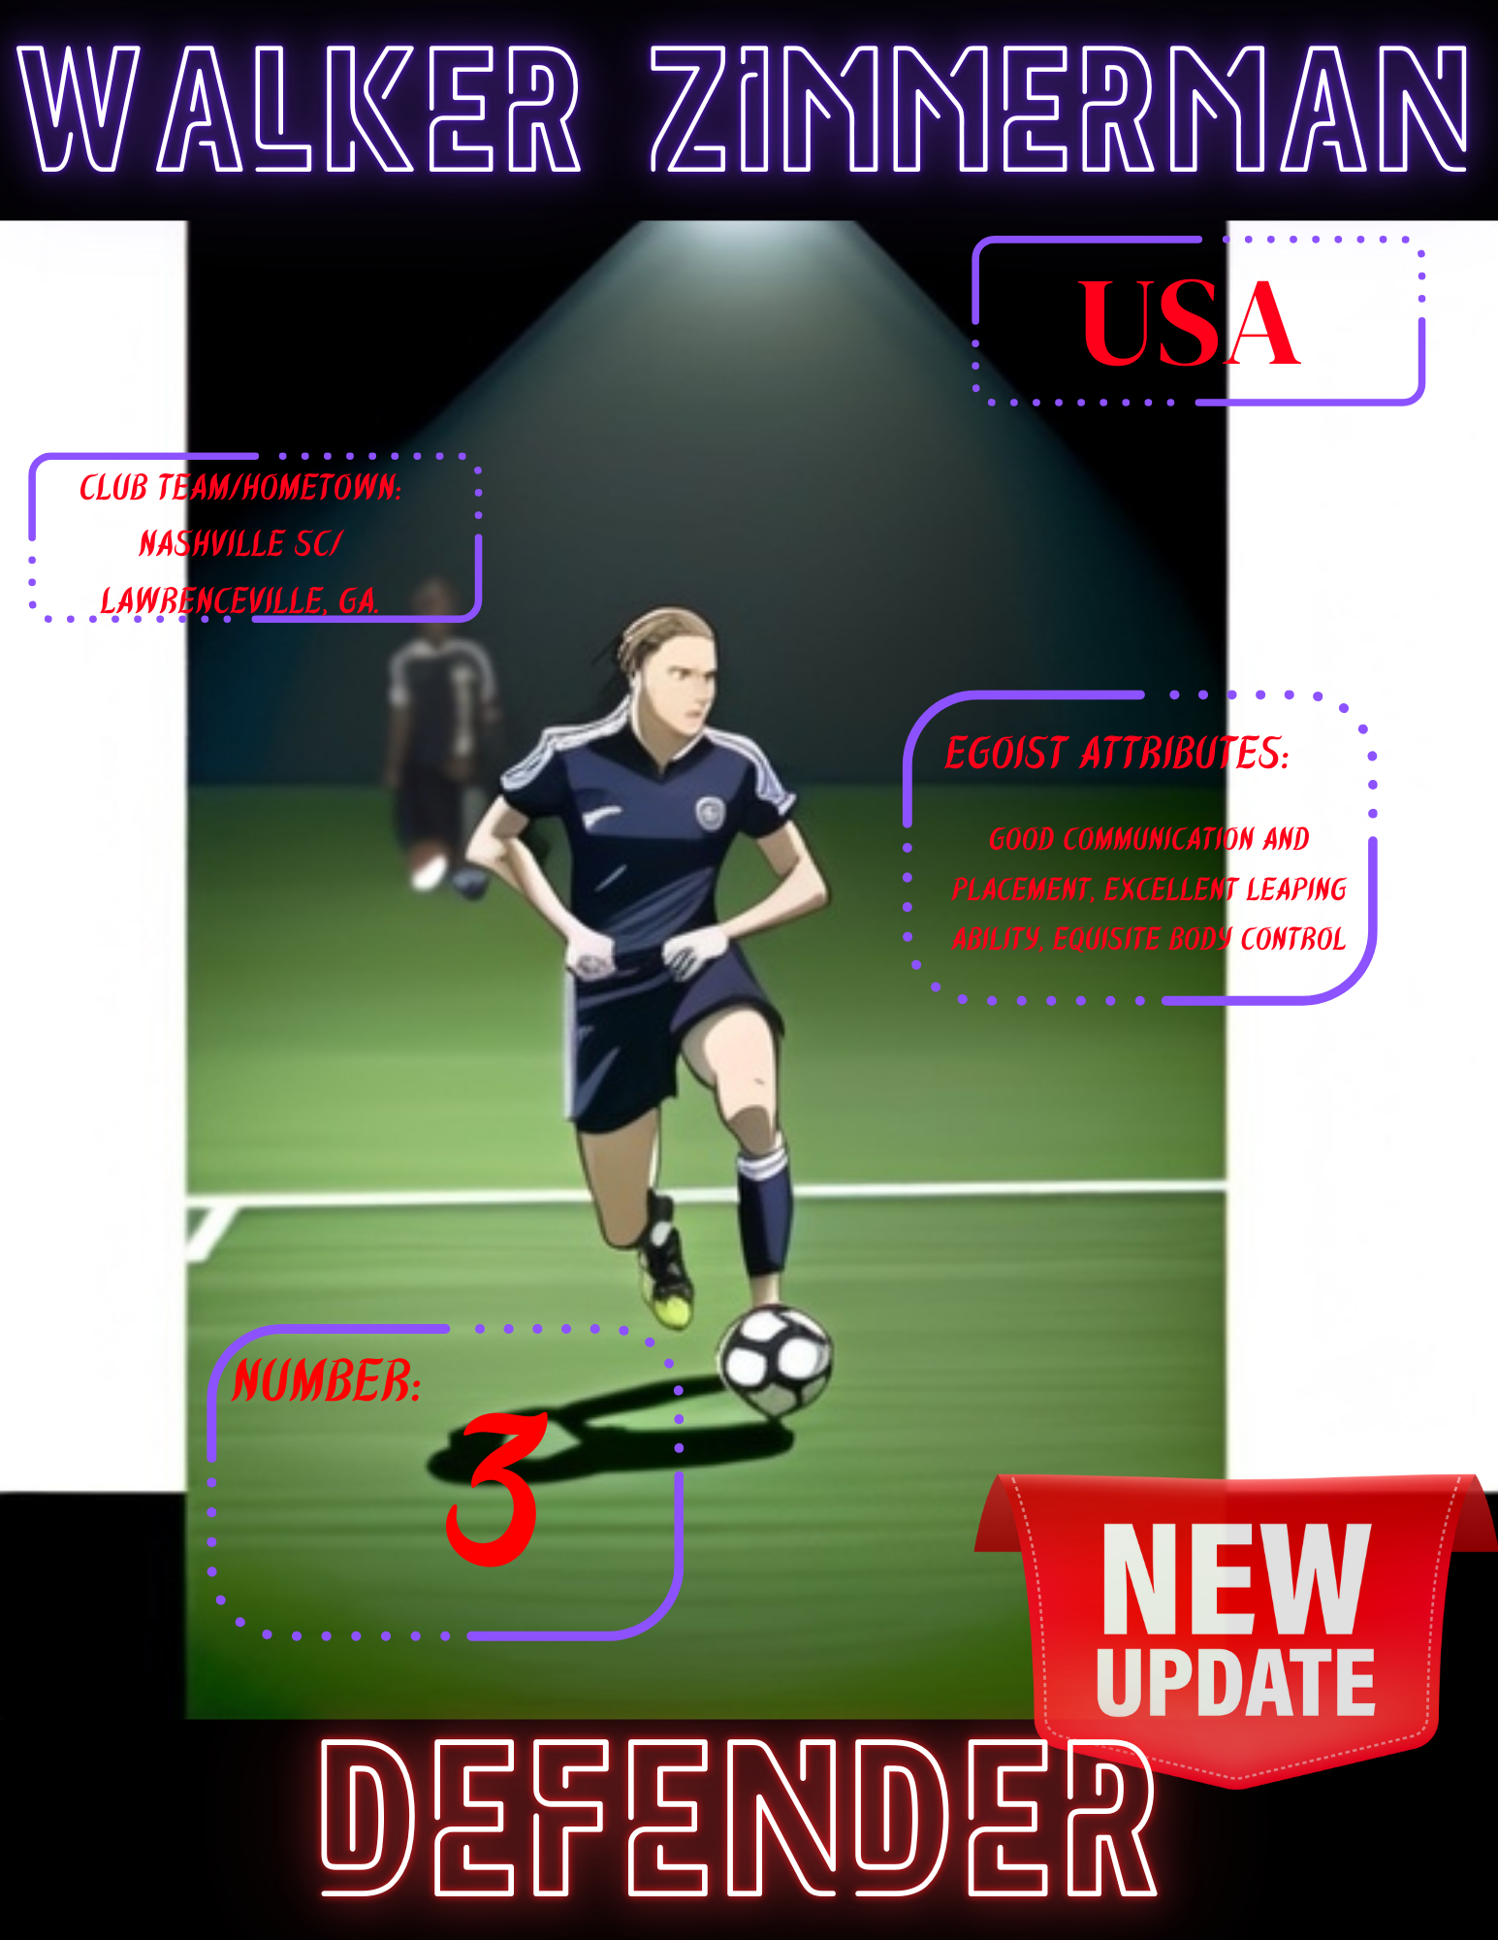
Team USA number 3, Walker Zimmerman, executed back to back brain boggling headers to set up a shot on the goal and to steal possession from Morocco

The rise of aggression came too late for the USA. Morocco followed with two goals in the second half. Their number 10, Ilias Akhomach, blitzed past Harriel to score a cross field ground kick to the right side in the 63rd minute.

Minutes later, their Captain and number 2, Achraf Hakimi, capitalized on a late closeout by Tolkin to score a smooth kick down the middle to the goal.

Security arose in an army as the game came to a close. The dignified and powerful atmosphere seemed directly out of a movie. The crescendo of the crowd seemed fitting for the game.

Morocco punctuated the win in the 91st minute with a final score by their number 15, El Mehdi Maouhoub, following a handball penalty.

Though descending the steps from glory accompanied a rush of pain, solace can be found in the fact that Team USA outperformed many expectations.

Their final record was 2 wins-2 losses and the birth of a new egoist, Kevin Paredes.

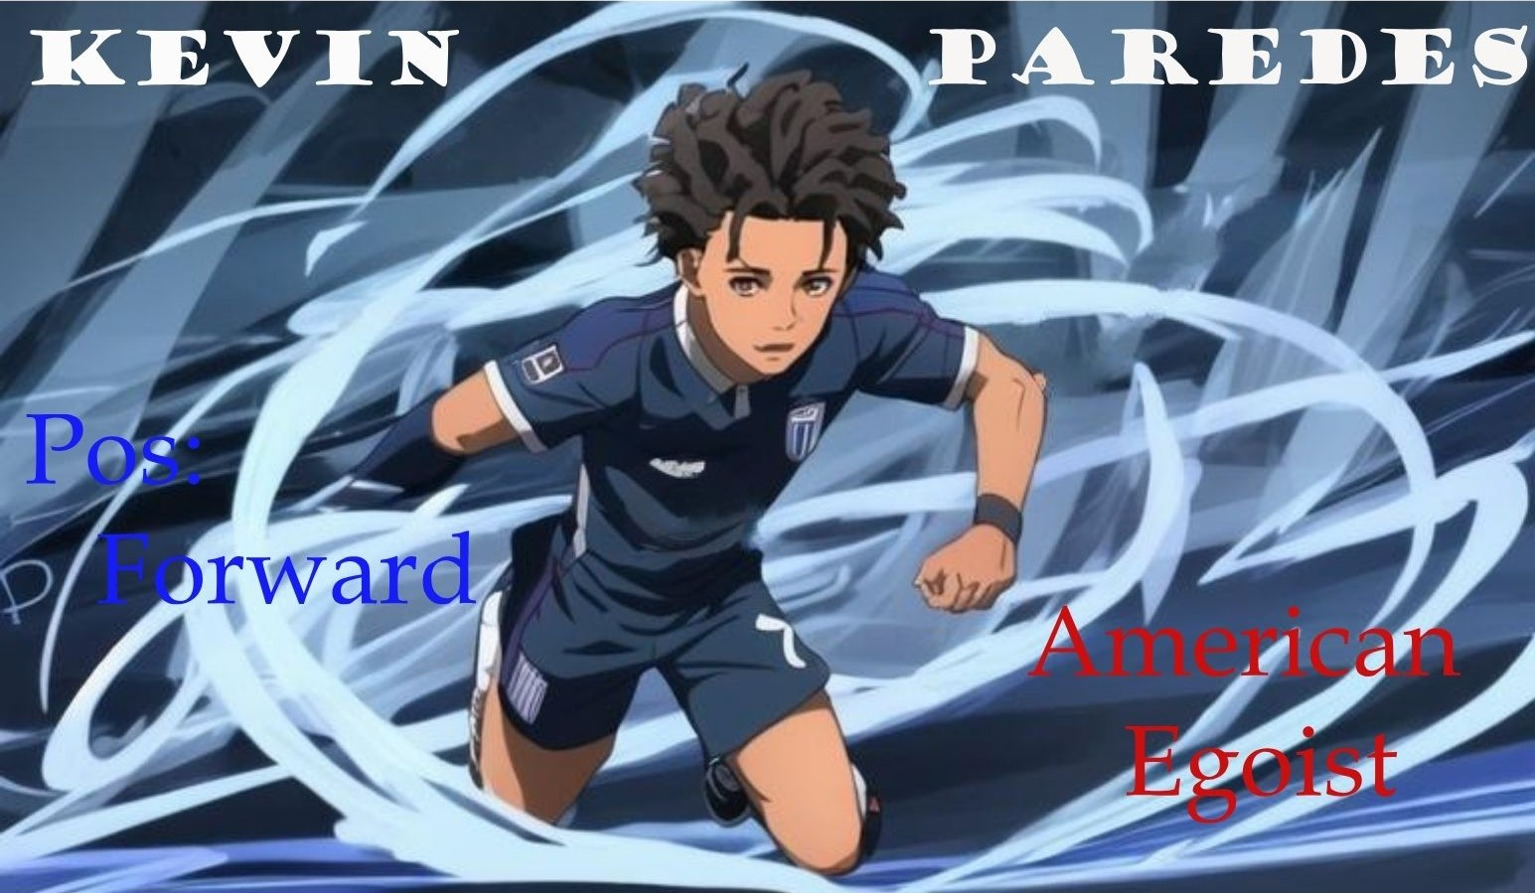

U.S. Olympic Men's Soccer Team vs. Morocco: Match Recap | 2024 Paris Olympics | U.S. Soccer Official Website (ussoccer.com)

