Charles James
Mc 3103 Apcar
12/5/23
Slice of Life

Into the Jaws of Tiger Stadium
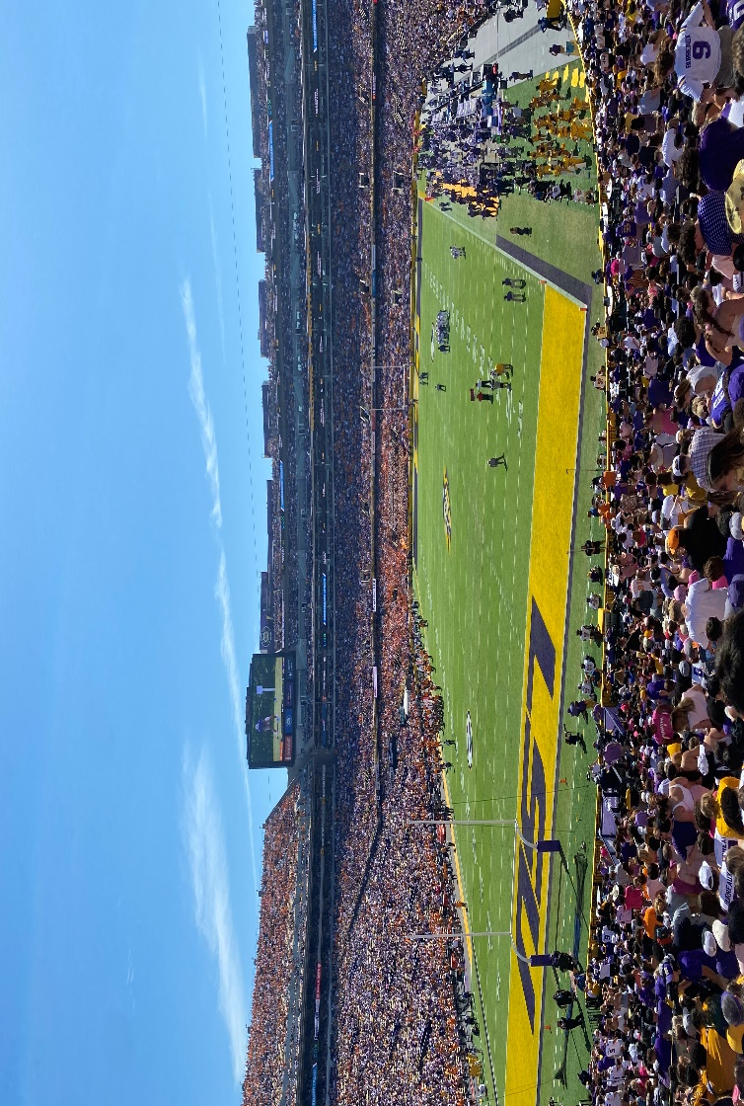
A loop, but never mundane.
If you do not like football, you should go to Tiger Stadium. The body-rattling noise that bombards the ears on game day will be your favorite experience. You thought this was a joke.
The only jokes are the victims… “opponents” who enter the jaws of Tiger Stadium and witness its roar.
Calm. Anxious. Thrilling. Heartwarming. Domination. Above all blessed.
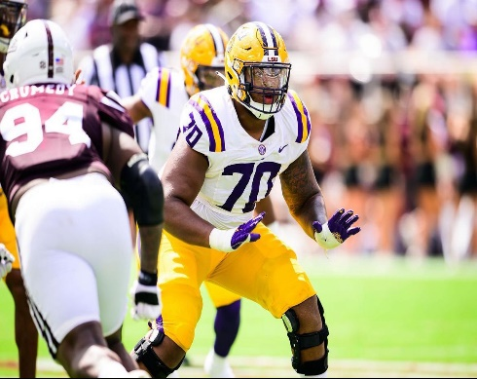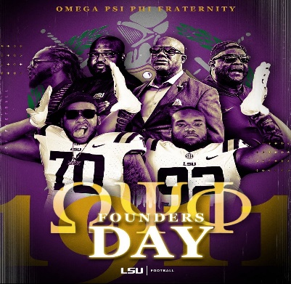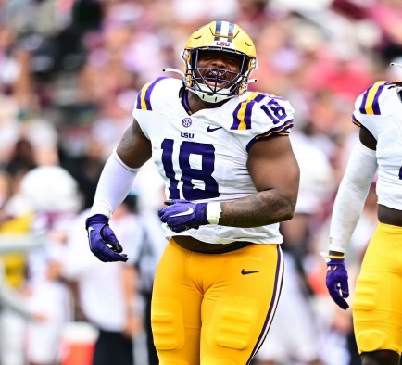
“Waking up on game day I’m just blessed. I worked so hard for this moment,” said starting Offensive Lineman Miles Frazier.
“It’s the most exciting day of the week for me,” said Captain and Defensive Tackle Mekhi Wingo.
The seemingly endless laps and hits all week led to this moment.
“Sometimes you want [the games] to be an all-day thing,” said Mykia McWilliams.
McWilliams is an LSU fashion student and Stylist Team Lead for the Maison Du Tigre LSU Fashion Magazine.

{Wakeup Call}
The wakeup call was at 8 a.m. Players got up early to play hard. The fans got up early to party harder. 8 a.m. was still a little early for them though.
Everything started with food. The football team had breakfast and a meeting. They began a walk-through without pads afterward.
The students and fans began their own walk-through.
“When I pick an outfit for game days, it’s got to be cute,” said McWilliams.
This Saturday she was no longer “drowning” in homework. McWilliams was not a football fan. She decided to give Death Valley a chance.

What is a game day without the perfect outfit? Sweatpants? The weather app advised residents of cold weather the day of the Texas A&M game.
The answer was yes. McWilliams stepped outside into the blazing sun. The answer was no. This is Louisiana, not New York.
“I stepped outside preparing for it to be cold,” said McWilliams. “It’s Louisiana, of course it’s not freezing cold.”
A white skirt, white jacket, bandeau top and a quick mirror selfie before the day began.

{Six hours to kickoff}
The team was having lunch. The fans were tailgating.
Music flooded the campus. Frats and sororities flooded the trash cans with vomit.
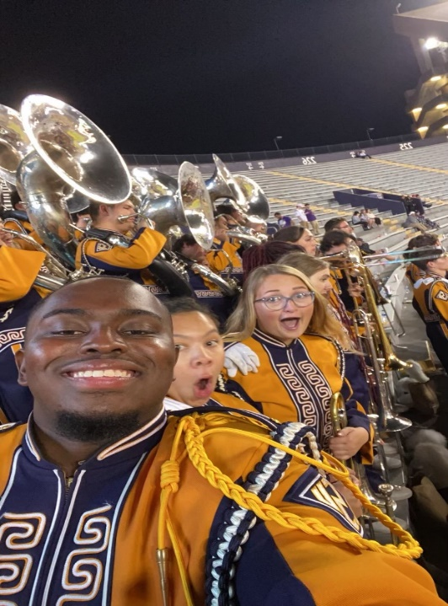
The school band prepared to later flood the stadium with a symphony of harmonic notes.
“Being in the band makes gameday an all-day affair which means there’s a whole lot of emotions behind it,” said Mark Reese.
Reese is a senior and a trombonist in the tiger band. He is also a member of the band fraternity Kappa Kappa Psi. The band prepared all week.
“We learn a new halftime show for every home game,” said Reese. “We have a week or two to learn each show.”
They had something special in store for LSU’s week 13 and final game against Texas A&M. The band finished their pregame and halftime rehearsals and ate lunch.
The members of the team were given time to rest and prepare themselves mentally. Wingo sometimes called his old teammates to discuss the different teams playing that day around the country.

{Preparing for Victory}
It came time for the team to dawn their best attire alongside the rest of the campus. Theirs was more business formal. Business is what they came for. Players came prepared to “stand on business” in a figurative sense as well as on their opponents in a literal one.
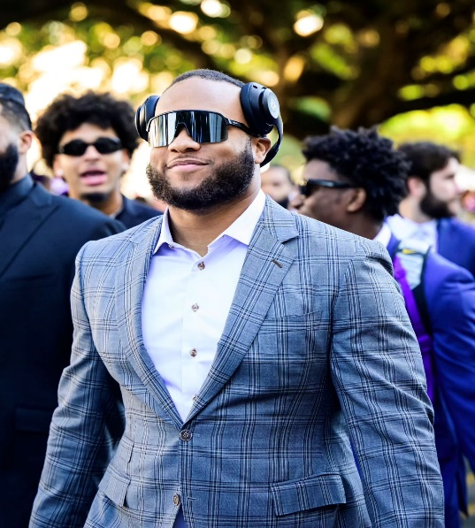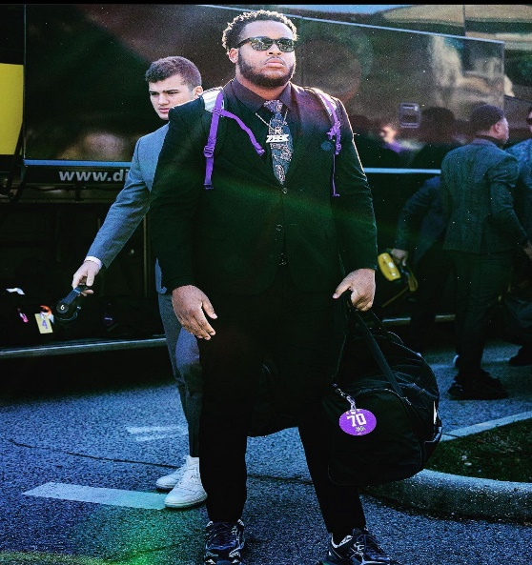
The band was doing their sectional warmups. These were songs that were typically written by a member of the section. It was a tradition that prepared them to perform.
Students across campus were tailgating.
A mix of R&B and Rod Wave floods through Wingo’s headphones. The tone switches to artists such as Lil Baby and NBA YoungBoy as the stadium approaches. Frazier’s was the same.
“That gives me the motivation,” said Frazier. “In those lyrics of those songs from this artist it mainly has a kill or be killed approach.”
LSU’s offensive line was named one of the 12 finalists for the Joe Moore award. This is given to the most outstanding offensive line in college football. Frazier played an integral part in this.
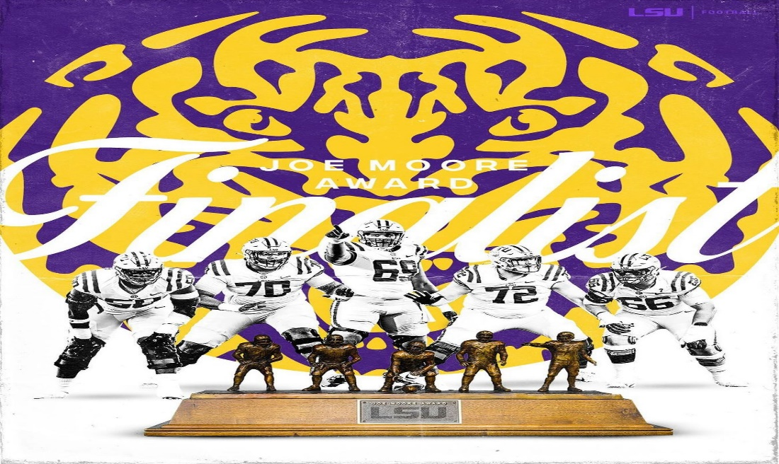
Jayden Daniels is a candidate for the Heisman trophy this year. Everyone wanted to make sure people knew it. Almost as if this was an actual discussion. #JD5forHeisman.
“Everybody’s kind of just happy to just be there and be in the moment,” said McWilliams.

{Game Time}
The great migration from tailgates to the stadium had reached a climax. The players rushed to the field.
“No matter who I faced, whether they were all conference or a first-round projection, I knew that I could go out and dominate them because I put in the work,” said Frazier.
The band played.
“Every weekend I get to perform for thousands of fans and continue a 130-year legacy,” said Reese of his impression on performing on game day.
The fans cheered.
“The energy was infectious,” said McWilliams. “The Energy was unmatched.”
McWilliams’s friend talked her through much of the game. She often did not know what was going on. She heard the people cheering. She knew the excitement. She knew that she felt it too.
“There was a moment at the Texas A&M game,” said McWilliams.
There was a catch. The receiver tumbled out of bounds. The crowd erupted with cheers. The referees said the catch was under review. The crowd erupted with boos. The call stood. It was a catch. The crowd erupted with cheers again!
“That was impressive,” said McWilliams. “I’m glad I went to that game to see, like to get to see that.”
The band impressed the world during their halftime show. Bands tend to “break the internet” when they perform one that is especially noteworthy.
The Tiger Band formed themselves into the Heisman pose. They were making a statement about Daniels to the world. Once again #JD5forHeisman.
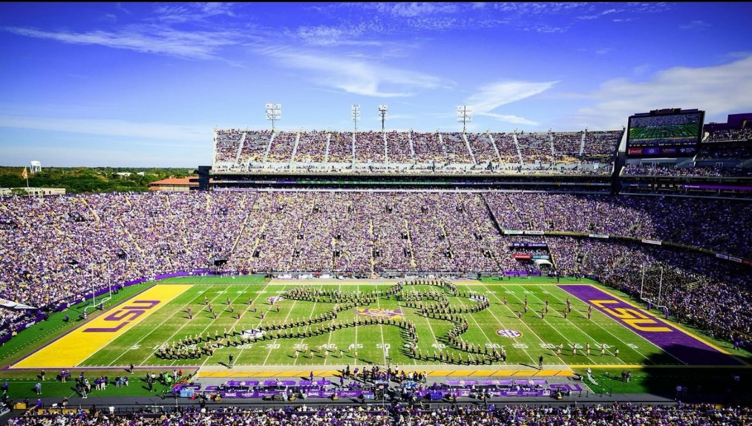
‘The game is only an hour,’ remarked Wingo.
These players pulled the heartstrings of thousands in this hour of action. They made a new fan on this day.
“I would buy the student package for the tickets if I could do anything differently,” said McWilliams.
Sources:

Mykia McWilliams, LSU fashion Student (interview 11/29/23)
Miles Frazier, LSU Football Player (interview 12/02/23)
Mekhi Wingo, LSU Football player (interview 12/02/23)
Mark Reese, LSU Tiger Band (interview 12/03/23)

