Companion Animal Alliance: The story of Grease Lightning

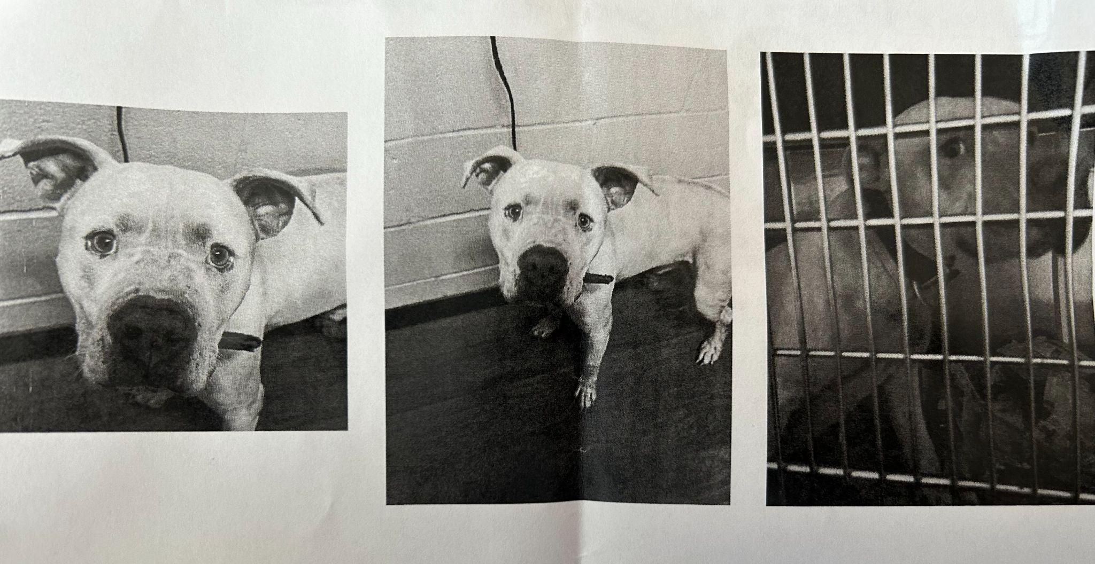

You pack your car. The children file in. Luggage to the brim in the trunk. New adventures add new avenues. They sometimes leave wagging tails behind.
These beautiful animals who became family are then discarded. Their fates then laid in the hands of the 50 workers of Companion Animal Alliance. These people would determine his future.
This was the case for a three year old Terrier and American Bulldog mix. His name was Grease Lightning.
Grease Lightning was picked up by animal control after being abandoned on the lands of his owner’s old home. He arrived at Companion Animal Alliance on March 21, 2023. His intake notes were stellar:

“Sitting quietly, wagging tail, giving kisses. Relaxed body language, affectionate x10. Possibly knows ‘sit,’ food motivated and gentle with treats. 10/10 good boy.”

Grease Lightning quickly became a favorite among the staff. He gave affectionate cuddling. He is polite and sat in front of doors when he wanted to leave. His training was evident and thorough.
However, the change from being with a family was painful nonetheless. He whimpered and begged as he was returned to his cage after a walk. He lumped his soft, pearly head into their arms. It is never easy.
Not every dog waddled through the door ready for a new family. Not every dog handled the pain easily.
“I want to say we get the best of the best… but we [also] get the worst of the worst,” said Sergio.
Jillian Sergio is the executive director of Companion Animal Alliance. She is a character who, just as the job description stated, “would [you] chase down a dog in heels.”
”Trying to find affordable animal housing in Baton Rouge? To be honest it’s a joke,” said Sergio in an interview, “especially if you don’t have a 10-pound poodle.”
Companion Animal Alliance, CAA, is located on Louisiana State University’s Baton Rouge campus at 2550 Gourrier Ave.
CAA does not receive funding from LSU. It has partner programs with the Veterinary School of LSU. Four students are present at all times for training. There is also an internship partnership with the School of Agriculture at LSU.
CAA, as the only open intake shelter of Baton Rouge, supports the lost and discarded animals of the entire area. The area spans 400,000 people.
The CAA shelter recently had an overflow of 323 dogs with the holding capacity of 177 dog kennels in February, according to The Advocate. As Covid arose, shelters and rescue programs shut down.
This resulted in a difficult balancing act between keeping access to adopting families while still maintaining security to prevent spreading the disease. Furthermore, as Covid arose, the unemployment put many in difficult financial situations leading to many abandoning their pets.
Other shelters are afforded the choice. CAA as the only open shelter of Baton Rouge that takes in all animals of all walks of life. CAA displays its mission as to give lost and abandoned pets a second chance.
When you are an open intake shelter you get “very little input” about what dogs you take in, said Sergio.
CAA took in 9,620 animals of varying species in 2021 and takes over 4,000 lost pets every year, according to their website data analytics.
Rescues in Baton Rouge have the luxury of declining pets at their leisure. It can be done on the grounds of already having two of the same breed. It can be done on the animal having an imperfect track record. CAA does not have this luxury.
“You don’t always know what background the pets are coming from,” said LSU mechanical engineering student Jaylen Boyd.
The influx of animals coupled to the number needing rehabilitation causes a rough disparity between animals coming in and animals leaving. This alone is a difficult balance. Adoption necessities make this harder.
“People want a dog, they’re going to get a dog. I’d rather them get them from here,” said Sergio.
The availability of volunteers has the power to save these pets. Claire Boles has volunteered at CAA for 4 years. Boles’s devotion to the cats doubled the 6 month adoption rates after she arrived.
“The Board is concerned the numbers were wrong,” Boles recalled of her conversation with Sergio. “You see a cat or a dog that finally sees its person. A light goes off,” said Boles.
Rehabilitation for the pets also does the same for the people.
“It’s therapeutic,” Boles said. “4 years ago I couldn’t have talked to you. I can talk to a group no matter how big about cats”
CAA hosted various events to reach different “realms” of people. One such is Beer Fest. This event has had wide success for the organization.
They also produced events to assist in adoption. CAA has a partnership with the Charles R. Kelly Community Center. The last Wednesday of each month from 8 a.m. to noon they hold an in-person giveaway of various pet necessities. The Charles R. Kelly Community Center is at 3535 Riley St.
Moreover, the Positive Alternatives to Shelter Surrender, PASS, helps to avoid the case of animals being trapped into the system of adoption if unnecessary.
Sergio personally expressed her will to do events with fraternities. Anthony Arinze, an LSU student and member of the Theta Kappa Chapter of Omega Psi Phi Fraternity, expressed that these feelings were mutual.
“We really wanted to do a dog yoga event,” Arinze said.
Sergio views CAA as the final step.
“We are a resort but we should be the last resort,” she said.
Often pets are lost within their community and are taken across town to shelters and rescues. Without proper notification, their families believe them to be stolen. Once at a shelter an animal only has a 20% reclamation rate. Conversely, if a resident goes door to door, the rate skyrockets to 80%, according to Sergio.
“Not everyone can volunteer but everyone can help in some way,” said Boles. “It’s the shoeboxes!” Shoeboxes. Shoeboxes. Shoeboxes!
Boles emphasized how something as small as a shoebox with a towel in it could make a kitten become more social. How social the animals are directly helped them get adopted.
CAA is calling for the entire Baton Rouge area to support its cause. One city. One open intake shelter. One joint mission.

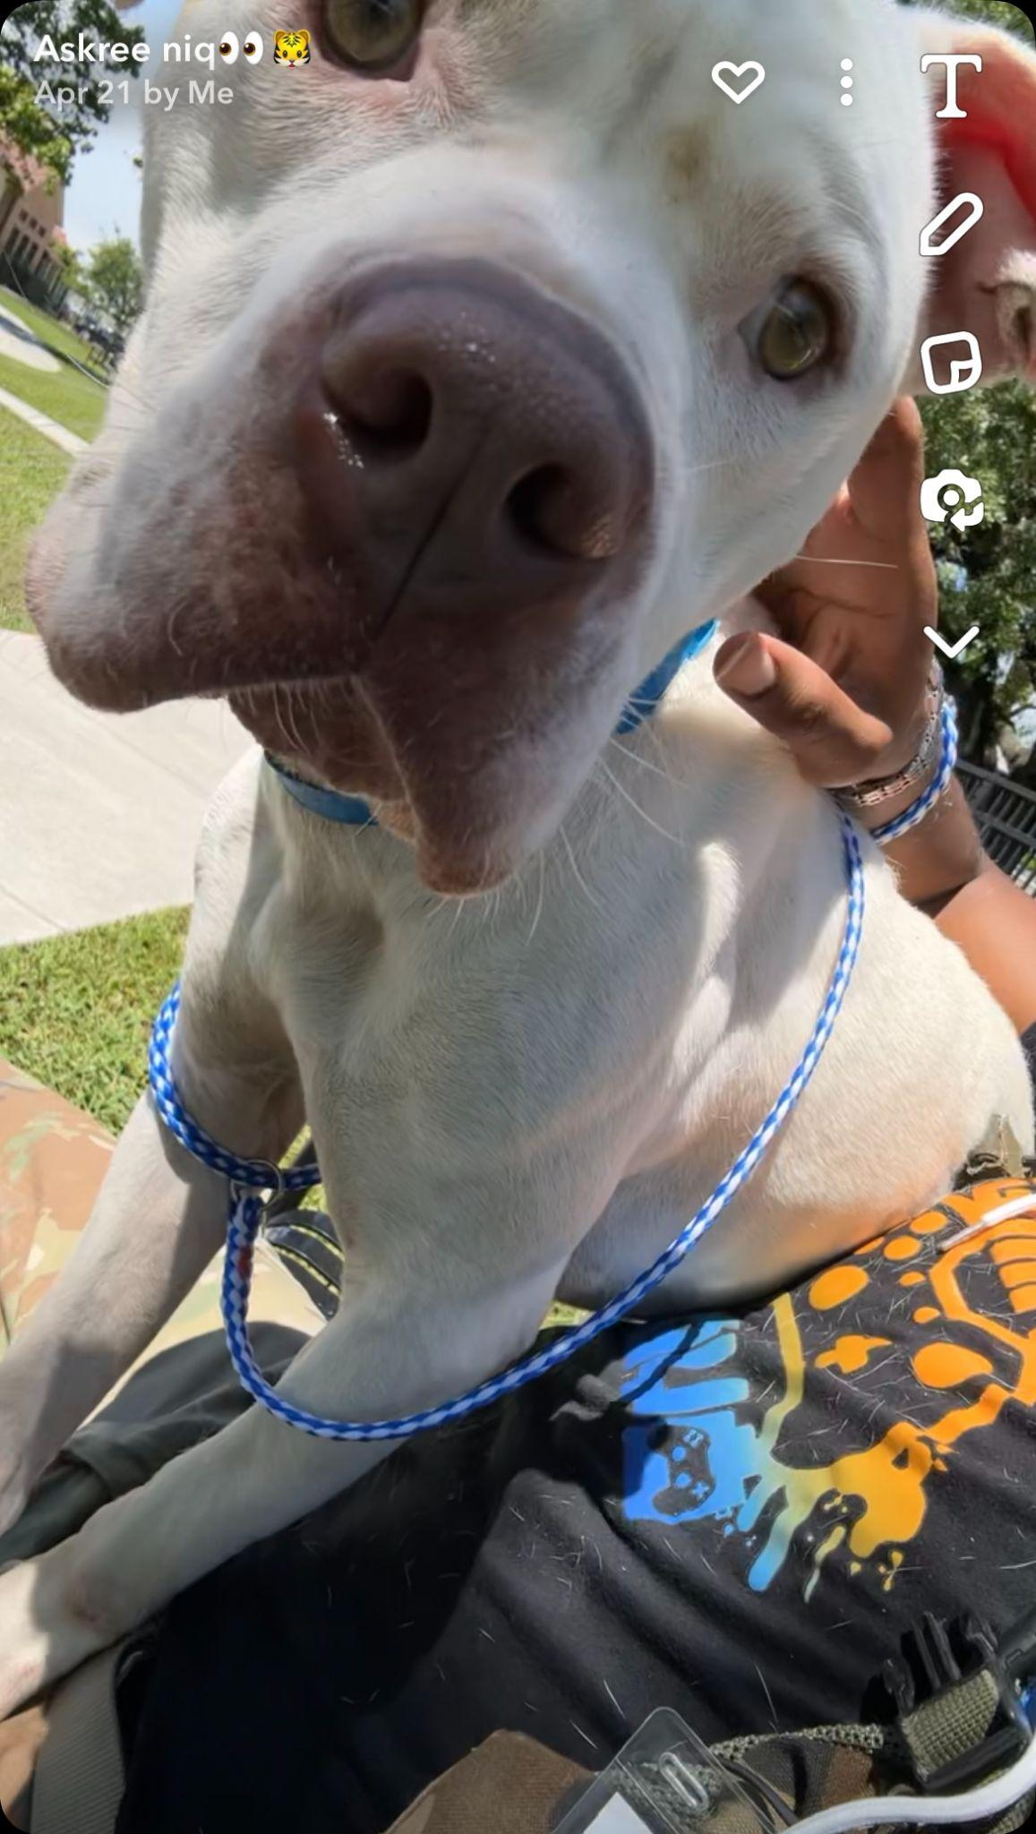

Sources:

Jillian Sergio
- Executive Director of CAA
- jillians@caabr.org

Claire Boles
- Volunteer at CAA
- claire7914@yahoo.com

Anthony Arinze
- LSU Student
- Theta Kappa Member

Jaylen Boyd
- LSU Student
- Theta Kappa Member

