America needs an Egoist:

USA v France U-23 Olympic Football
Written by: Charles James IV Edited By: Charles James Art By: OpenArt Starter

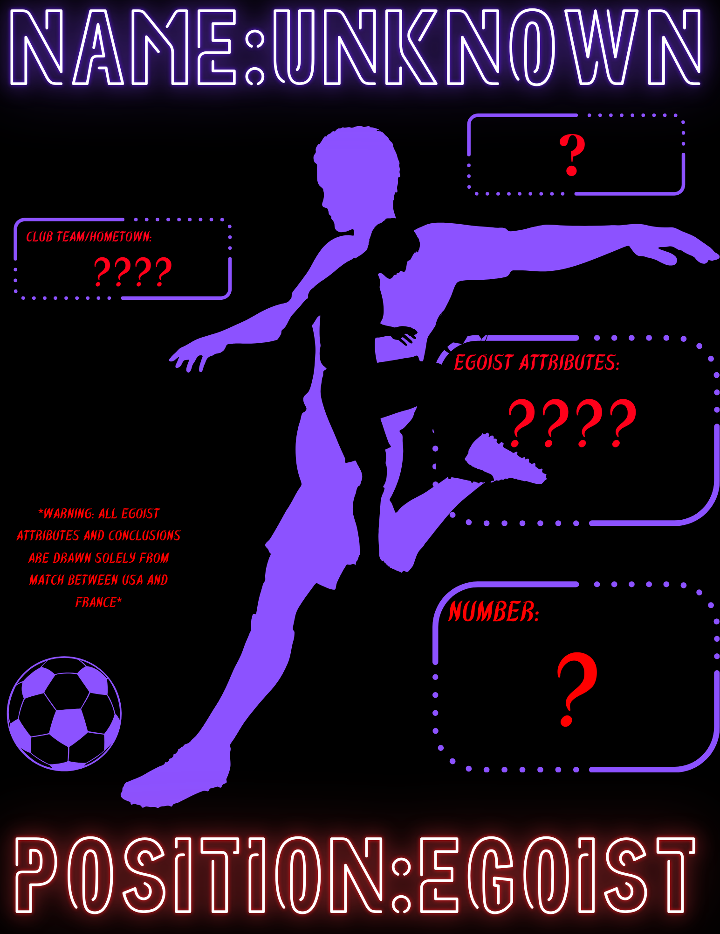
Soccer at its core is a game of instinct and strategy. Sometimes the former is buried by the latter. This seemed to be the case in the first half of the 2024 Olympics U-23 football opener between France and USA.
In the words of Blue Lock character Jinpachi Egos, “soccer is about one thing. Scoring more goals than your opponent does. Whoever scores the most is the best, end of story.”
Egos often preached the idea of an “egoist.” This was a player with the innate and unparalleled devotion to scoring. He claimed a true “egoist” not only knew they were the best, but had the power to subjugate even those who thought the same.
The score of 3-0 in favor of France at first may be misleading. Teams were scoreless until the final thirty minutes of the game. This is telling as various sources have named France a favorite to win the tournament.
Roddy Cons of AS USA remarked that “France have got more talented players than the USA” in his “France 3-0 USA: full-time thoughts” post.
The overarching outlook contradicts reality. One must contrast the occurrence of these goals with the lengthy period prior.
The land of freedom adorned a pure white. The French “Allez Les Bleus” dawned a cool blue. Their colors seemed to reflect their play styles.
Team USA often sought to slowly progress backwards to create heavy spacing. This was followed with fervent dashes down the middle and long cross field passes. It mirrored the unveiling of a huge canvas followed by the bold strokes to outline the overall image. This is fitting for a team that many believe is in search of true identity; a true “egoist” if you will.

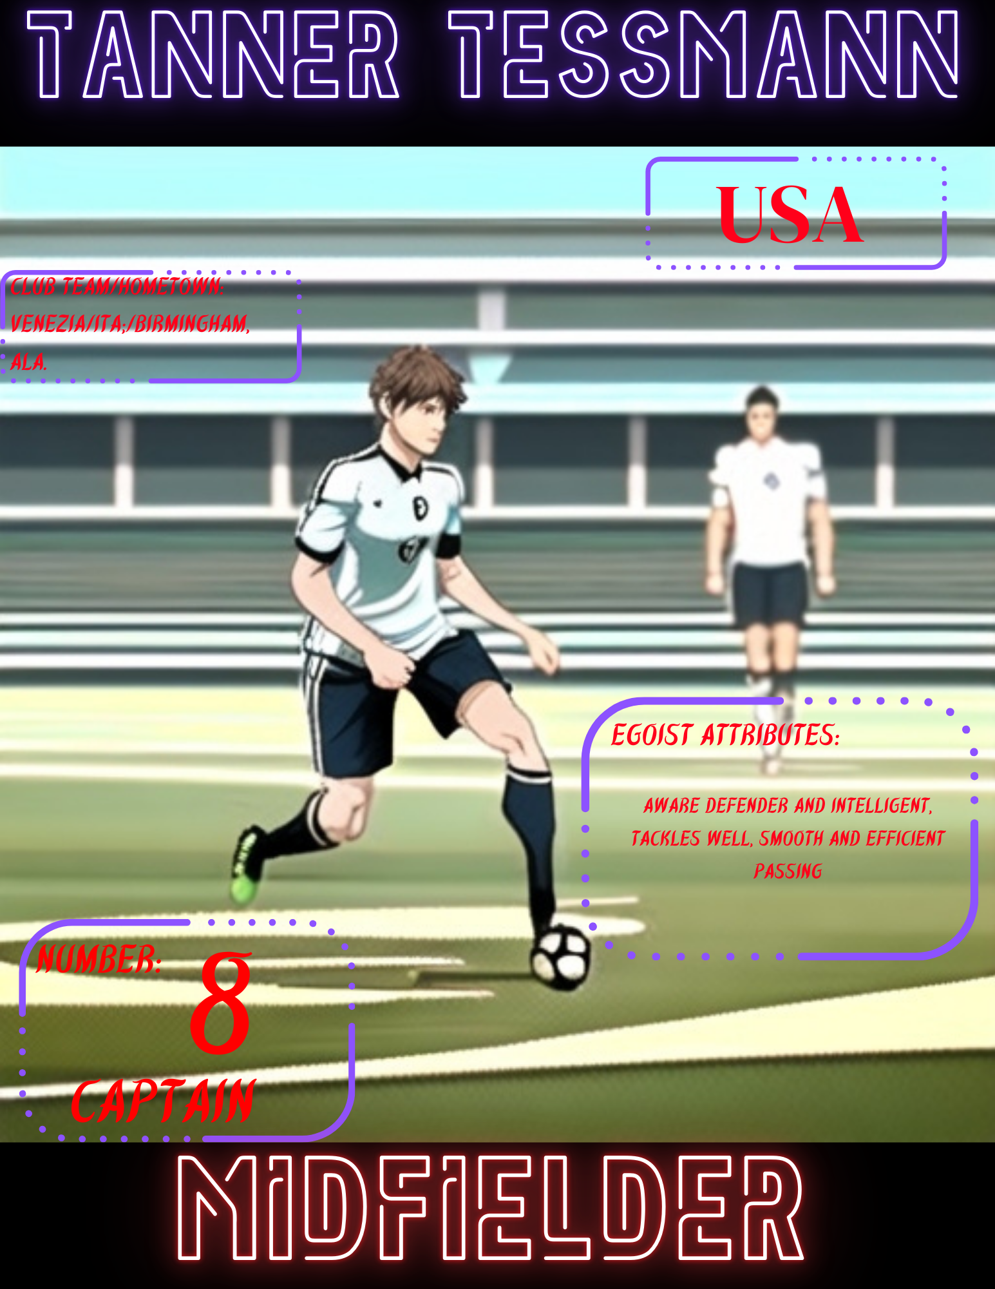

Captain of Team USA was Midfielder Tanner Tessman. He executed and directed both sides of the field efficiently. Tessmann placed the ball often into key spots for his teammates to strike with quick splices down the middle between defenders.
There was frustratingly little progression despite an aggressive strategy. This was not exclusive to the USA team alone though. France was unable to peel away easily from the USA’s stifling defense.
Team France focused on lateral movement. They heavily utilized short passes. Their play mirrored the waves of the sea as they calmly waded forward across the field.
The stadium’s atmosphere seemed to model this style, at times literally. A sea of fans jumped out of their seats and raised hands to the sky. The familiar tradition of doing “the wave” rippled for many rotations around the stadium.

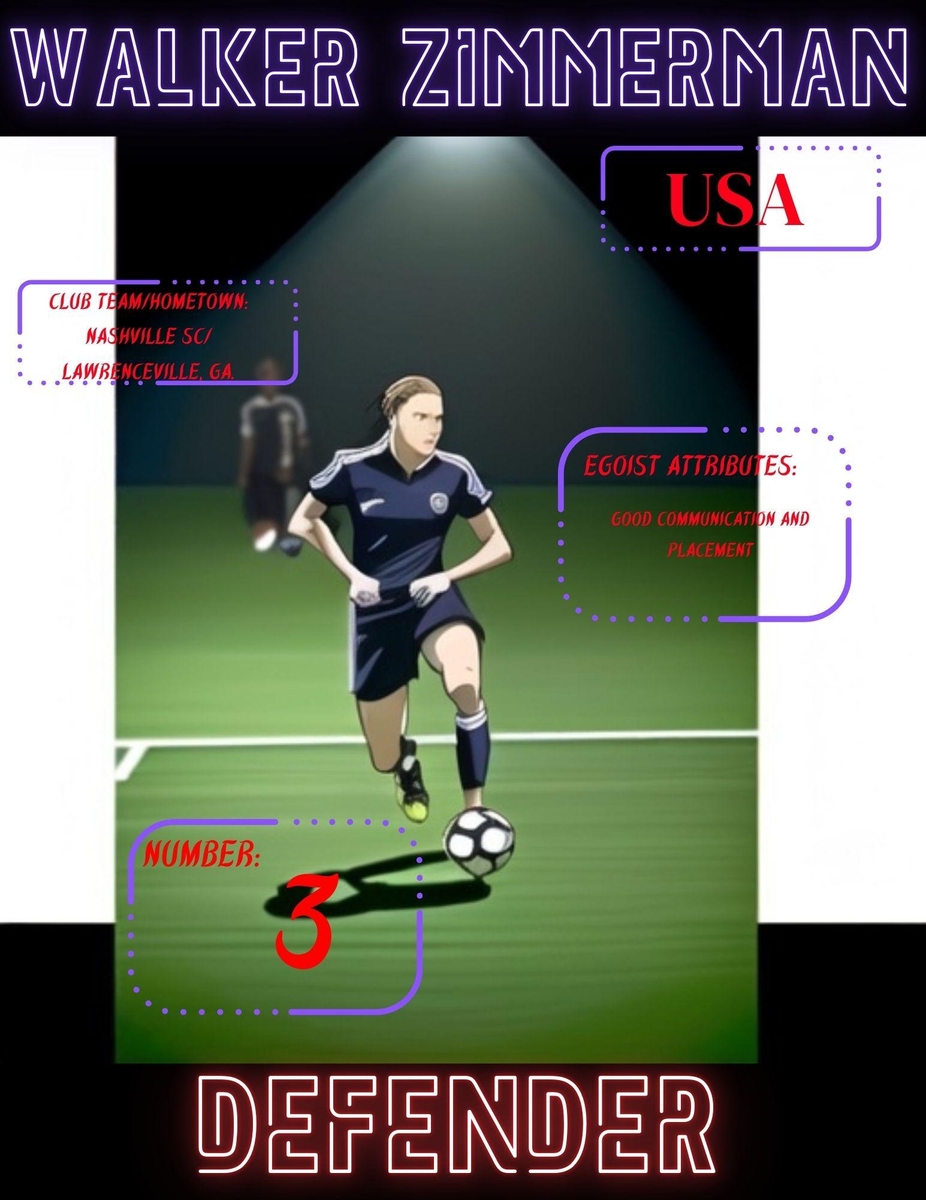

USA was particularly stout defensively along the edges of the field in the first half. Harriel and Zimmerman executed smothering doubles at edges that caused many losses of possession for France.

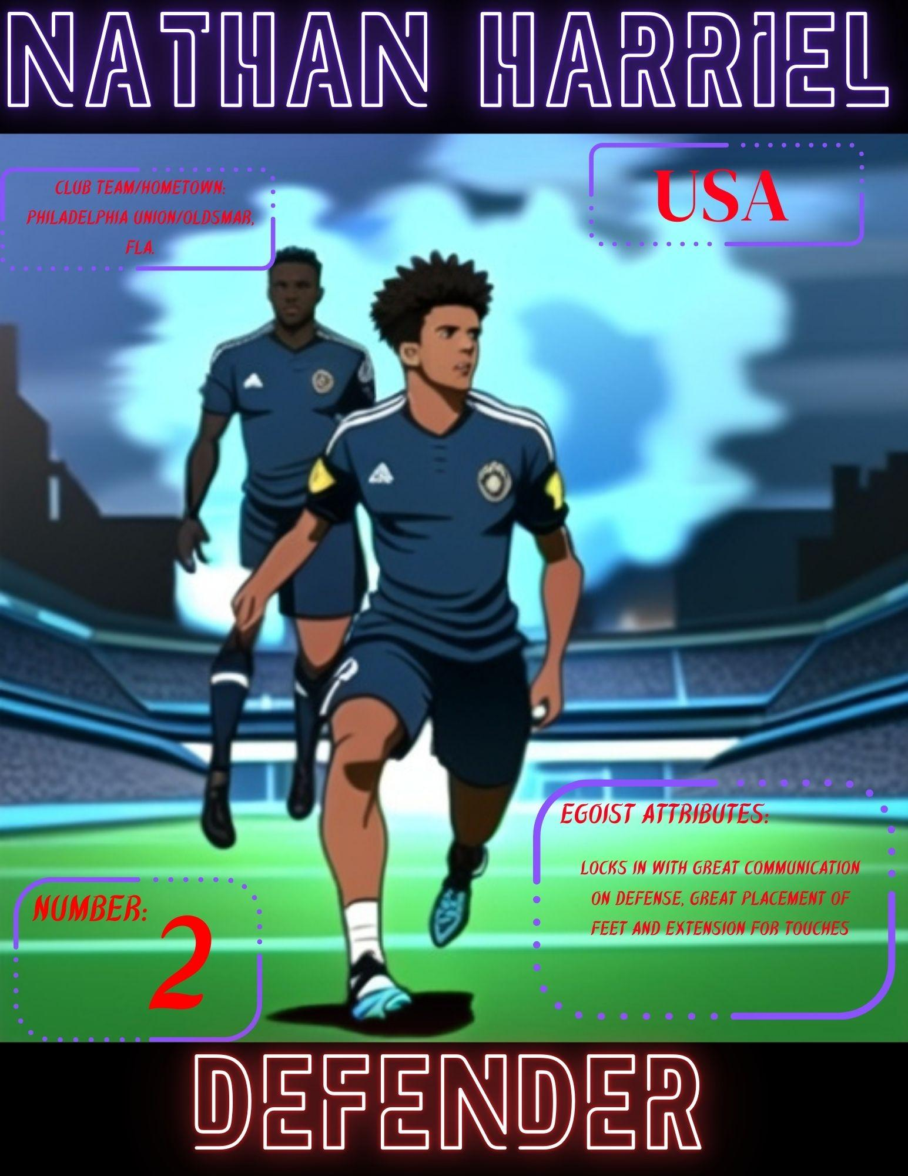

Harriel showed true devotion in his willingness to sacrifice his body to defend against a corner kick from France. He glided beautifully between the incoming ball and the intended offensive. Furthermore, he dispelled the course of the ball and absorbed the contact from the offensive simultaneously.

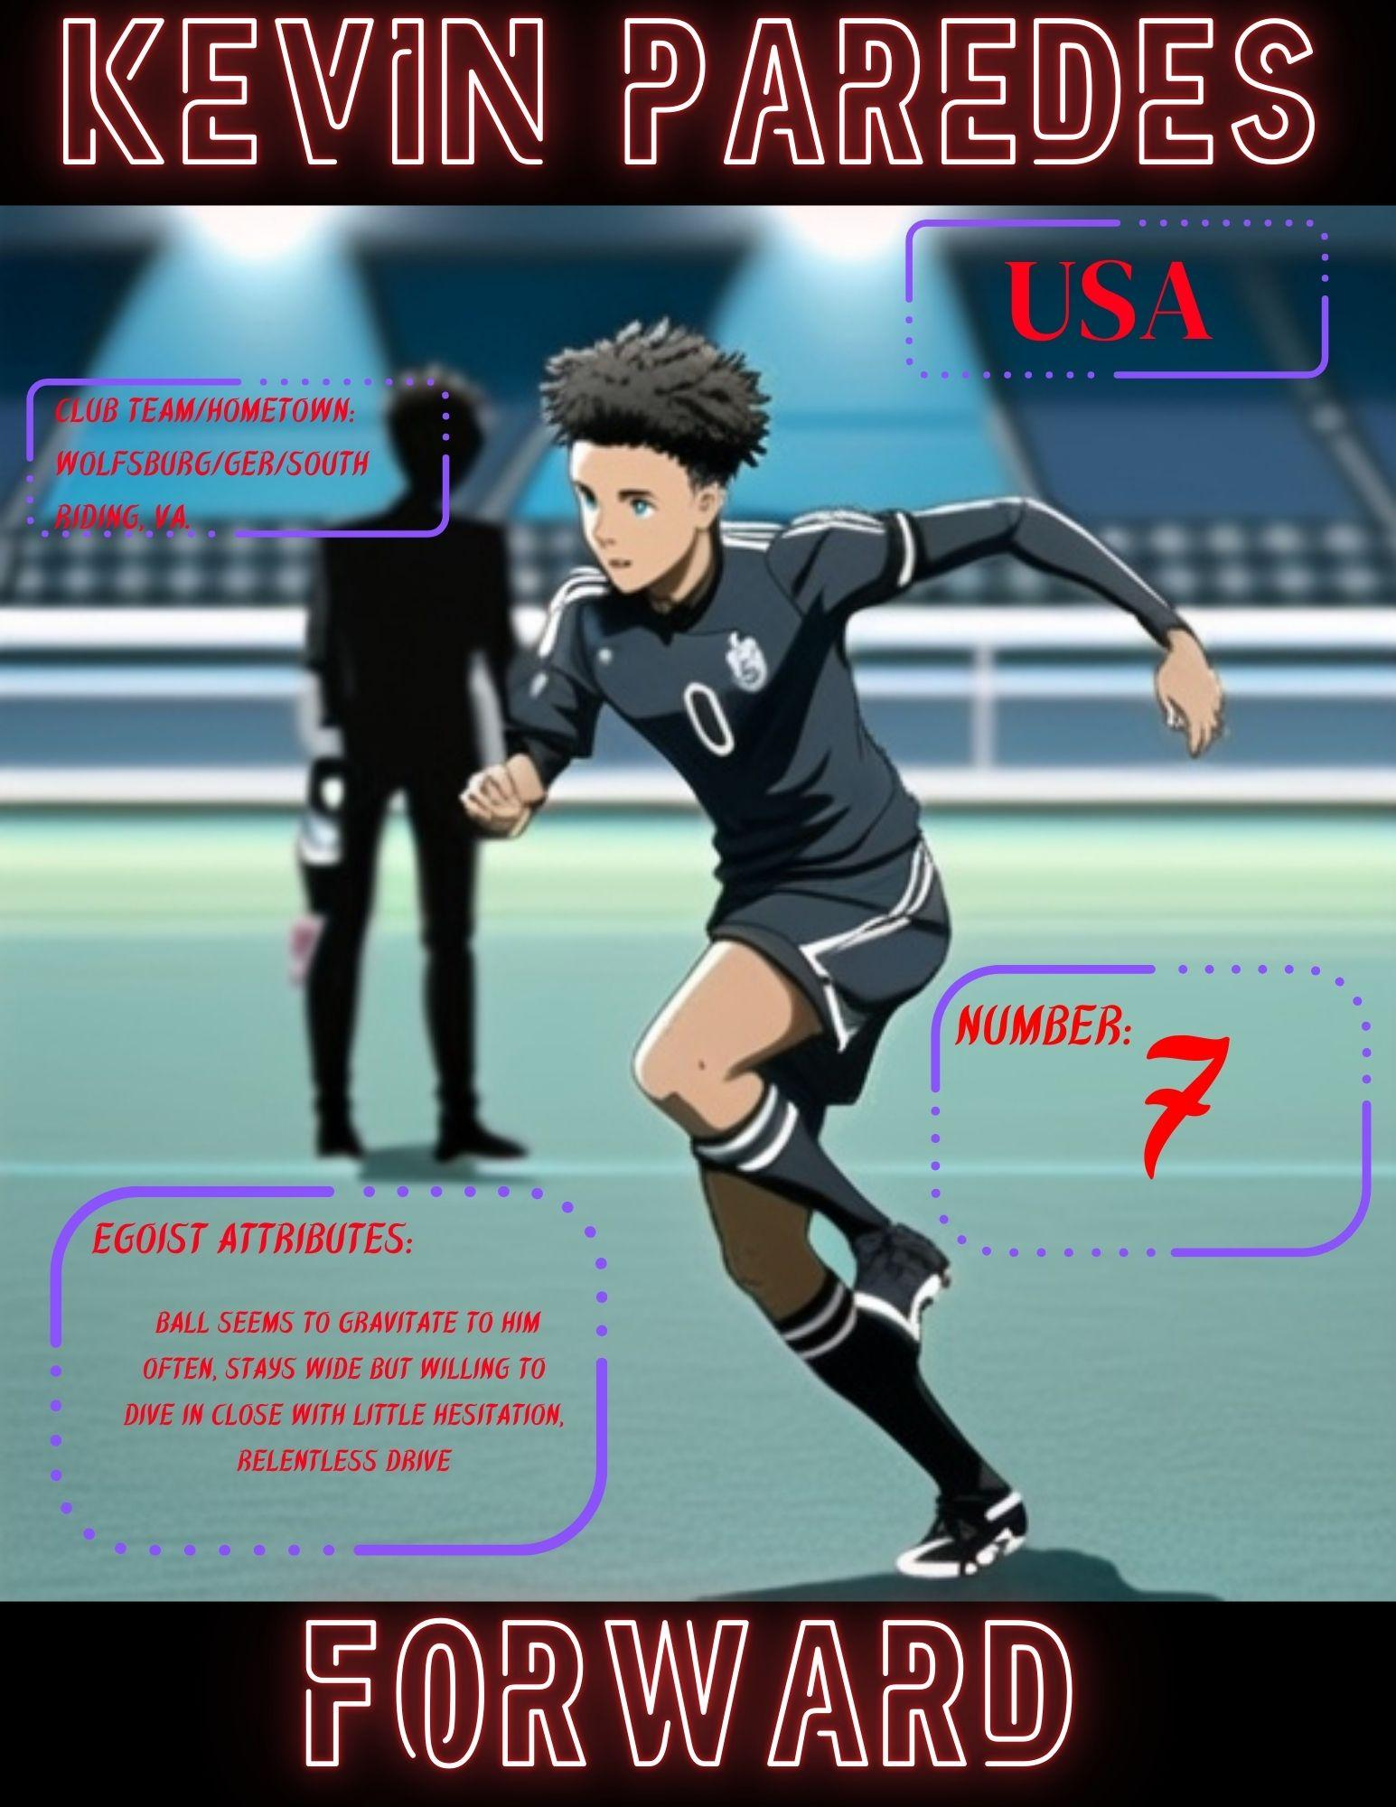

Strategy paves the way to victory, however, instinct and action are what determine its capture. A recurring trend of instinct led the ball to arrive under the legs of Kevin Paredes.
His passion and tenacity were on full display despite failing to overcome the defense. Most notably in a familiar rush past defenders down the right edge of the field. One of France’s defenders managed to trip Paredes. He plowed into the ground, yet he did not stop.
Immediately, he dragged himself forward to the ball and attempted another run with defense hot on his trail. Once again, he was tripped and thwarted. Paredes managed a perfect placement pass to a teammate despite the voracious defense attempting to smother him.

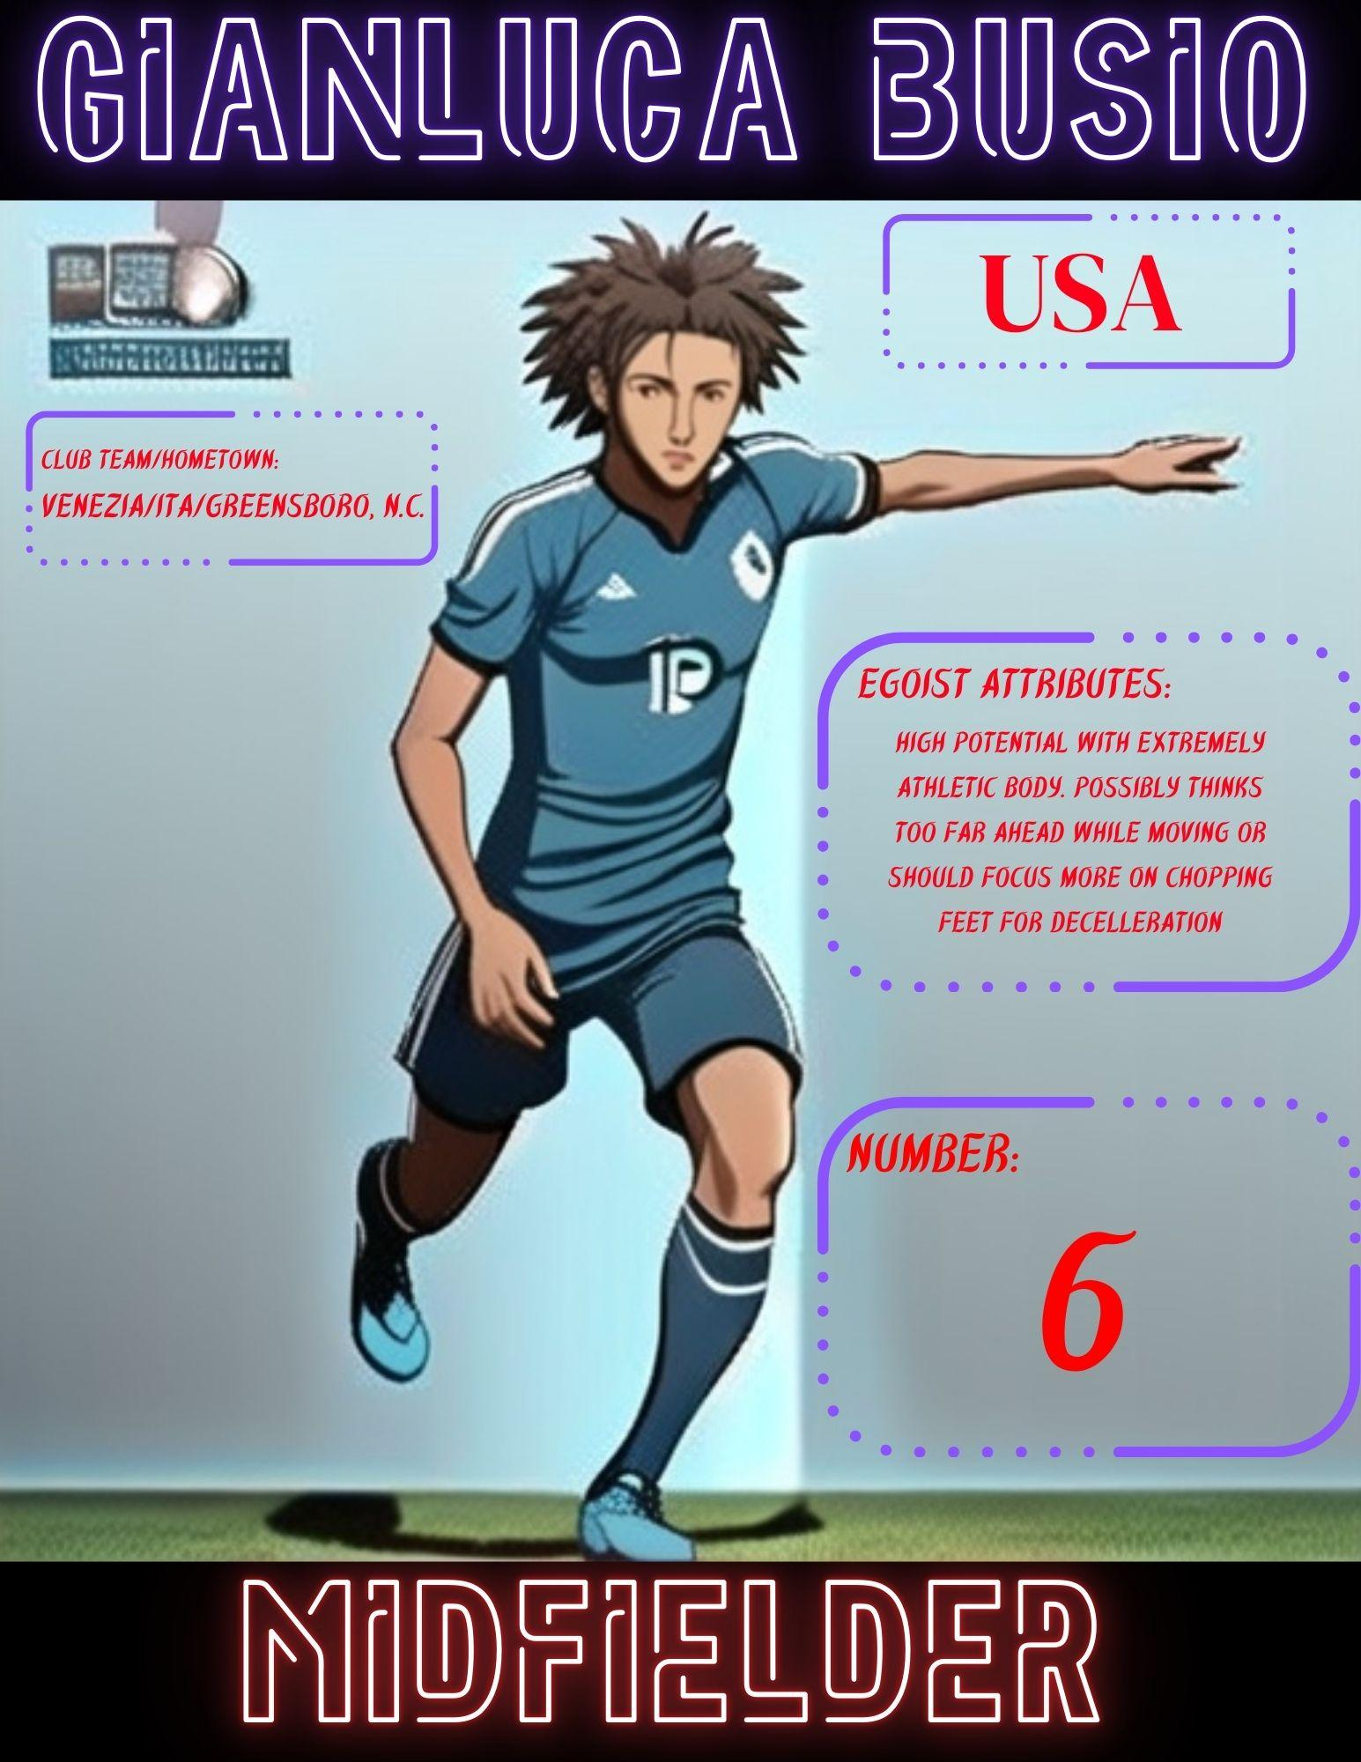

Midfielder Gianluca Busio carried a similar nose for opportunity. However, there were many instances where Busio was found head level with the ball whilst far from the goal. It must be noted that he moved with dazzling speed and maintained quick rebounding reflexes despite these many falls.
Busio also exhibited one of the sparse highlights of smooth dribbling during this contest. He utilized an exquisite sideline maneuver to avoid two defenders nearing the end of the first half. This was later followed by a good shot between defenders, yet the trajectory lacked the necessary curvature and speed to elude France’s goalkeeper.
The extent of Busio’s endurance was evident as well as he could be seen with a noticeable limp for a time during the late first half. He would later exit the game for a short period during the second half before returning.

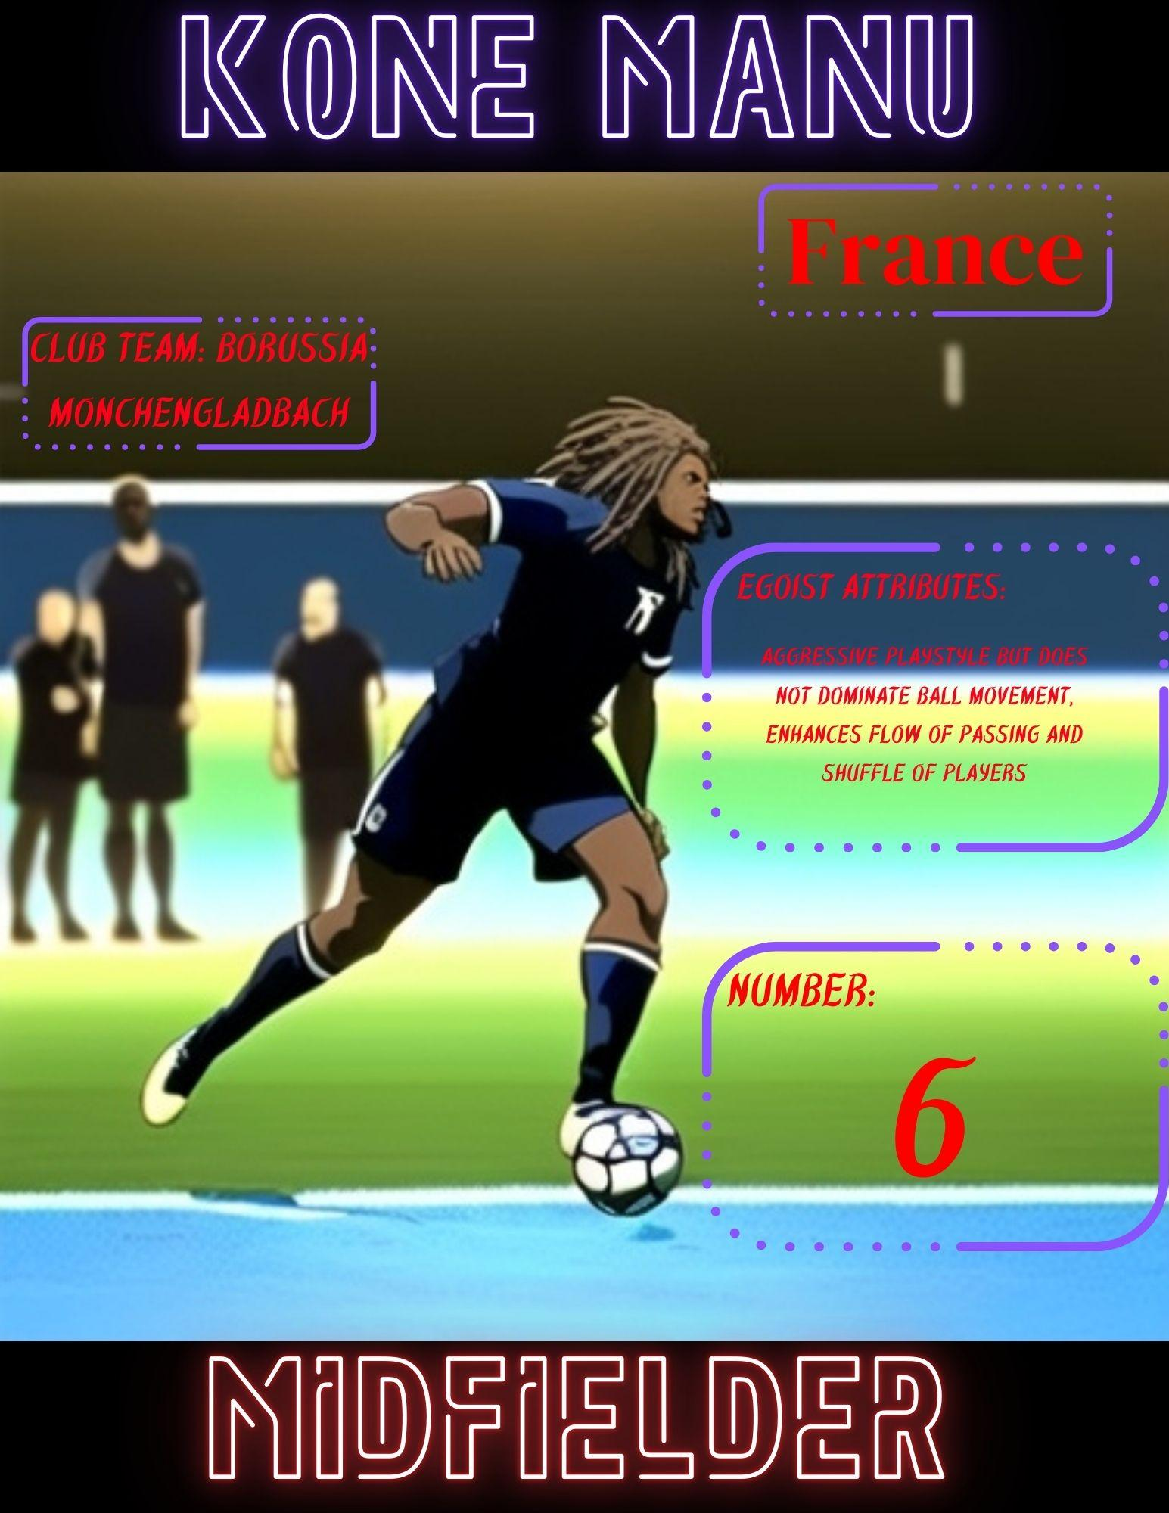

The shot by Busio was an ironically shared experience for both teams as France’s Kone Manu, also number 6, was involved in a similar shot at the goal on the other end. The parallels run deeper when examining the use of the physical tools Manu possessed.

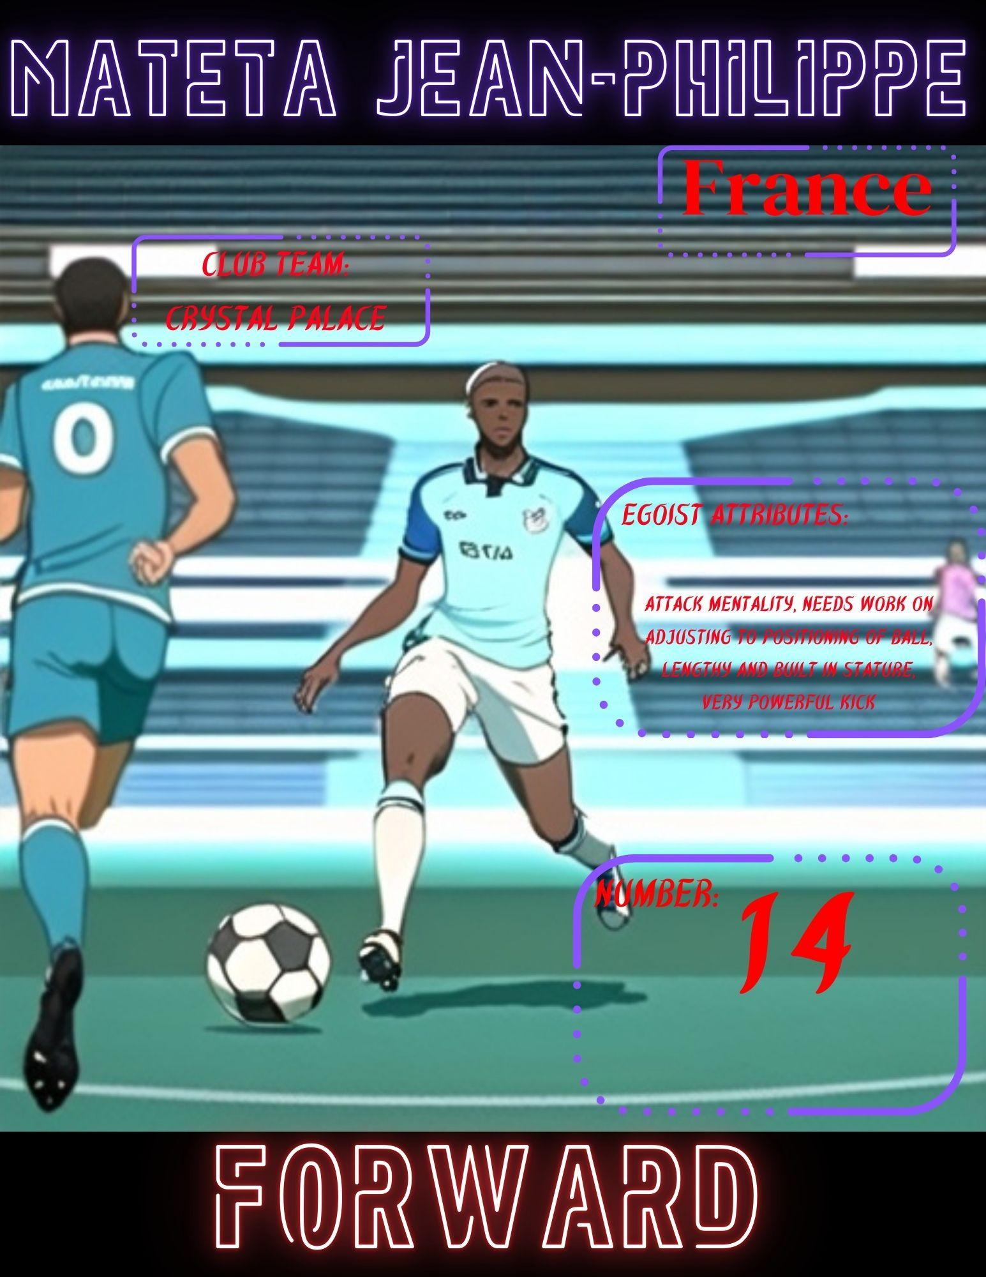

As noted by the various sources of the football reporting spheres, Manu was simply one gem amongst many on this star-studded French team. Mateta Jean-Philippe exhibited forceful yet elegant shots. However, these shots often were slightly askew of the goal during the first half.

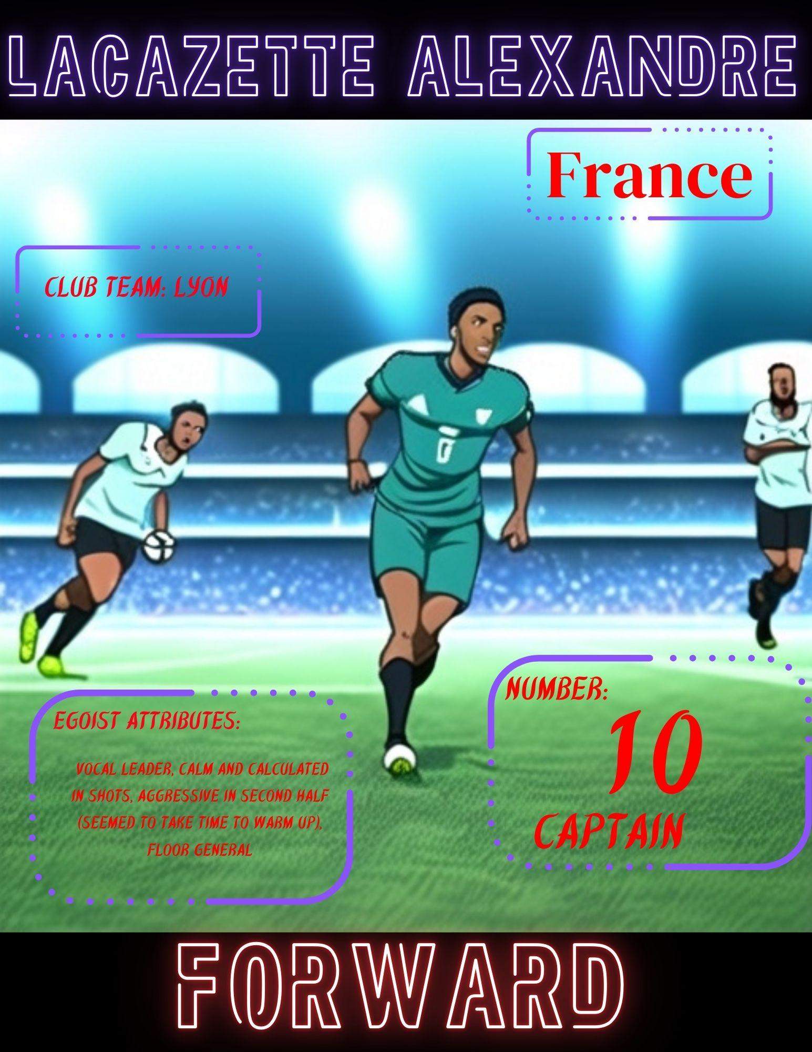

To close out the half, France’s captain and designated egoist, Lacazette Alexandre, made a swift show of skill. He aggressively split the defense, but made no clear intention to score at the time. It appeared as though he was prodding the USA’s defense for a future strike.
The return from the halftime break validated the prior appearance. Alexandre could be seen on the large screens in the corners of the arena as France reentered. He was giving a quick and emphatic message to his team.
Soon after Alexandre scored the first goal for the game. He executed a blazing cross kick from the right side of the field into the far-left corner of the goal. The ball blasted fourth from his feet at exuberant speed along the ground.
This was the crack in the dam that released the flood. France would score two more goals in the final thirty minutes of the game.
The USA continued ferociously and fought to the end. However, when lost amongst the waves of the sea, it takes time to find shore and balance. One goal was achieved before the concluding strikes of the clock. Alas, the goal was recalled due to an offsides.
This loss can spark a flame under the USA U-23 team. A flame from which an egoist can rise like a phoenix.

