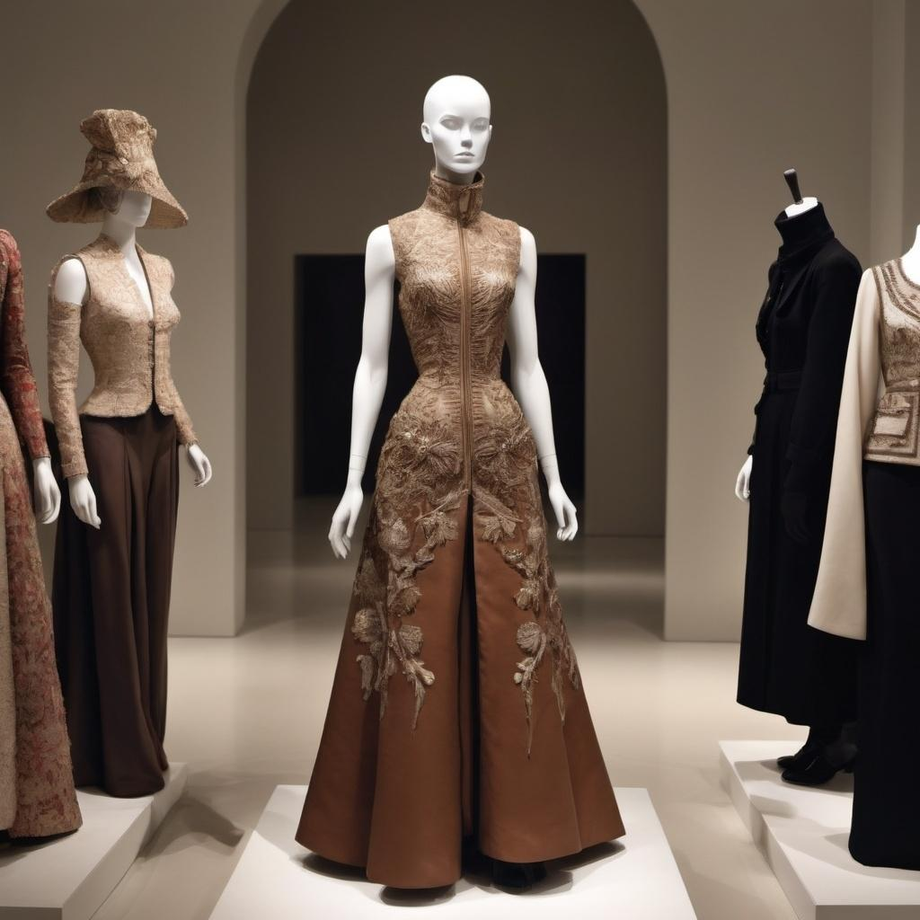

Turn on Roddy Rich for Paris, the city of “High Fashion.” Fashion enthusiasts, such as Bethany Rooney, may prefer the aura of Haute Couture began by Charles Frederick Worth.
Though different both in genre and generation, the similarity to contemporary style associated with the title of “High Fashion” is worthy of examination. Hence, Rooney has spoken upon the topic of French fashion following her three week summer course at the American University of Paris.
“Obviously, I would say that a very prominent age of French fashion would have to be the 19th century [birth of Haute Couture],” said Rooney. “ However, I would also say that the 20th century was a major turning point for French fashion.”

Haute Couture directly translates to “high sewing” or “high dressmaking.” It refers to the surge of made-to-order high quality fashion often made with expensive fabrics and intricate hand techniques. This was especially prominent in Paris, though it was seen in other fashion capitals around the world.

This was a time of slim fitting extravagant dresses that caught the eye due to sheer elegance of craftsmanship. The realm of Haute Couture has since expanded.

Contemporary French fashion utilizes more ready-to-wear clothing. It is the application and conglomeration of pieces that creates high fashion rather than the individuality of clothing.

“I found that top designer brands do not depict one’s social class,” stated Rooney.

The key lies in fashion sense. Rooney described her personal fashion sense as “comfortable in a flattering way,” but does not limit herself to any single style. She cited boho-chic and streetwear styles in particular amongst her favorites.

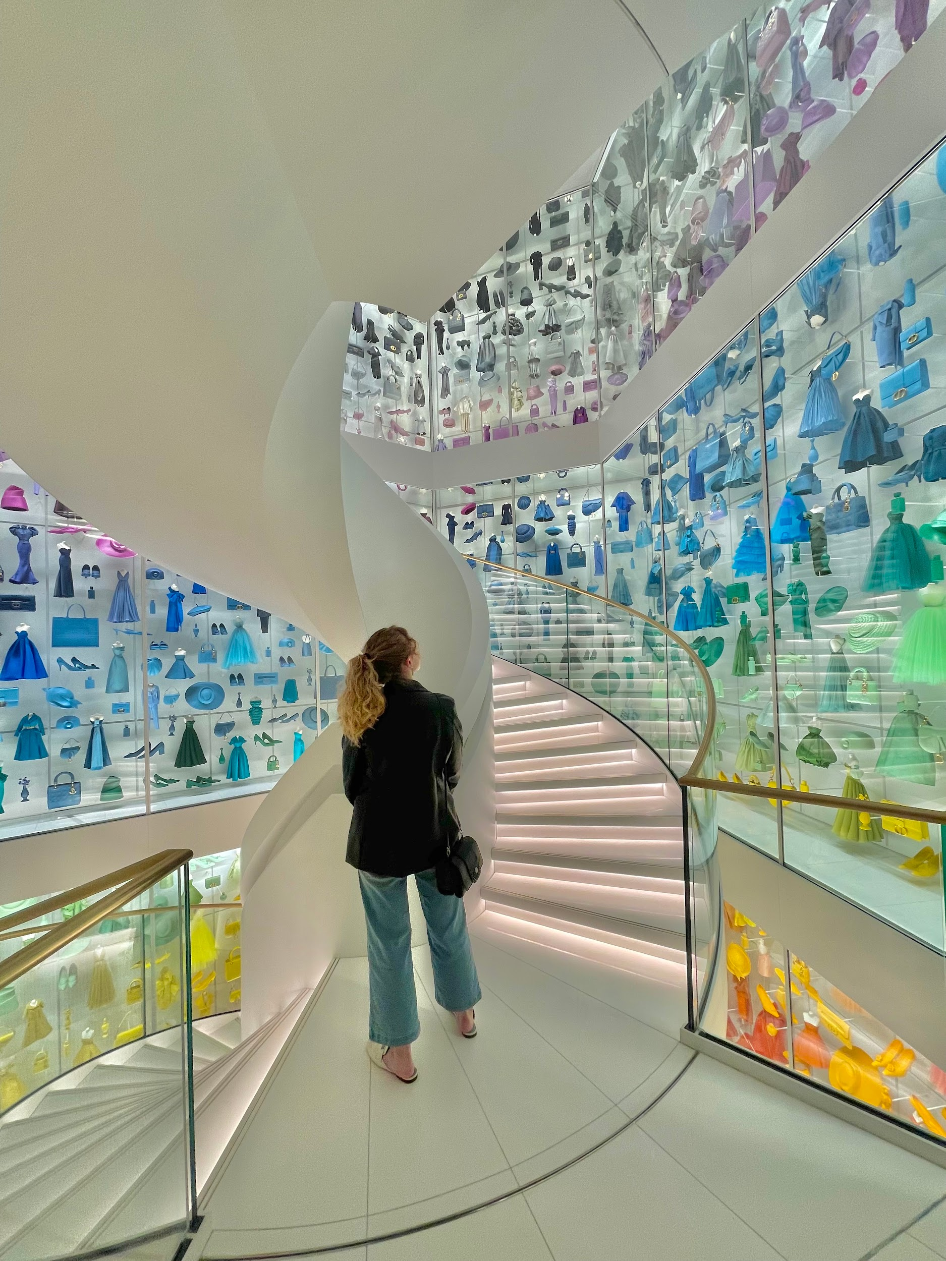

Her key is to balance not being too subtle without being spotted miles away. *Rooney’s style would not be considered a JoJo’s villain reference*

Contemporary French fashion can be attributed to subtle eye-pleasing tones with splashes of vibrant color. This style is perpetrated and pioneered by current Fashion Forces such as Coco Chanel and Christian Dior. They have revolutionized fashion.

The great architects of the fashion firmament continue to pass down their knowledge. Rooney’s professor, Nadia Albertini, found it imperative to utilize experiences rather than solely lectures to imprint the ideals and tactics of textiles.

A particular experience that resonated with Rooney was in le Musee de Arts Decoratifs. In this museum, a magnificent piece’s presence had slipped Albertini’s mind. Albertini had one of her designs, a balmain jacket, adorned for display in the museum. She is a testament to the ideals of Psalm 11:2 that wisdom accompanies the humble.

“Instead of waiting for us to praise her for her design, she immediately began to teach us how she created it,” stated Rooney.

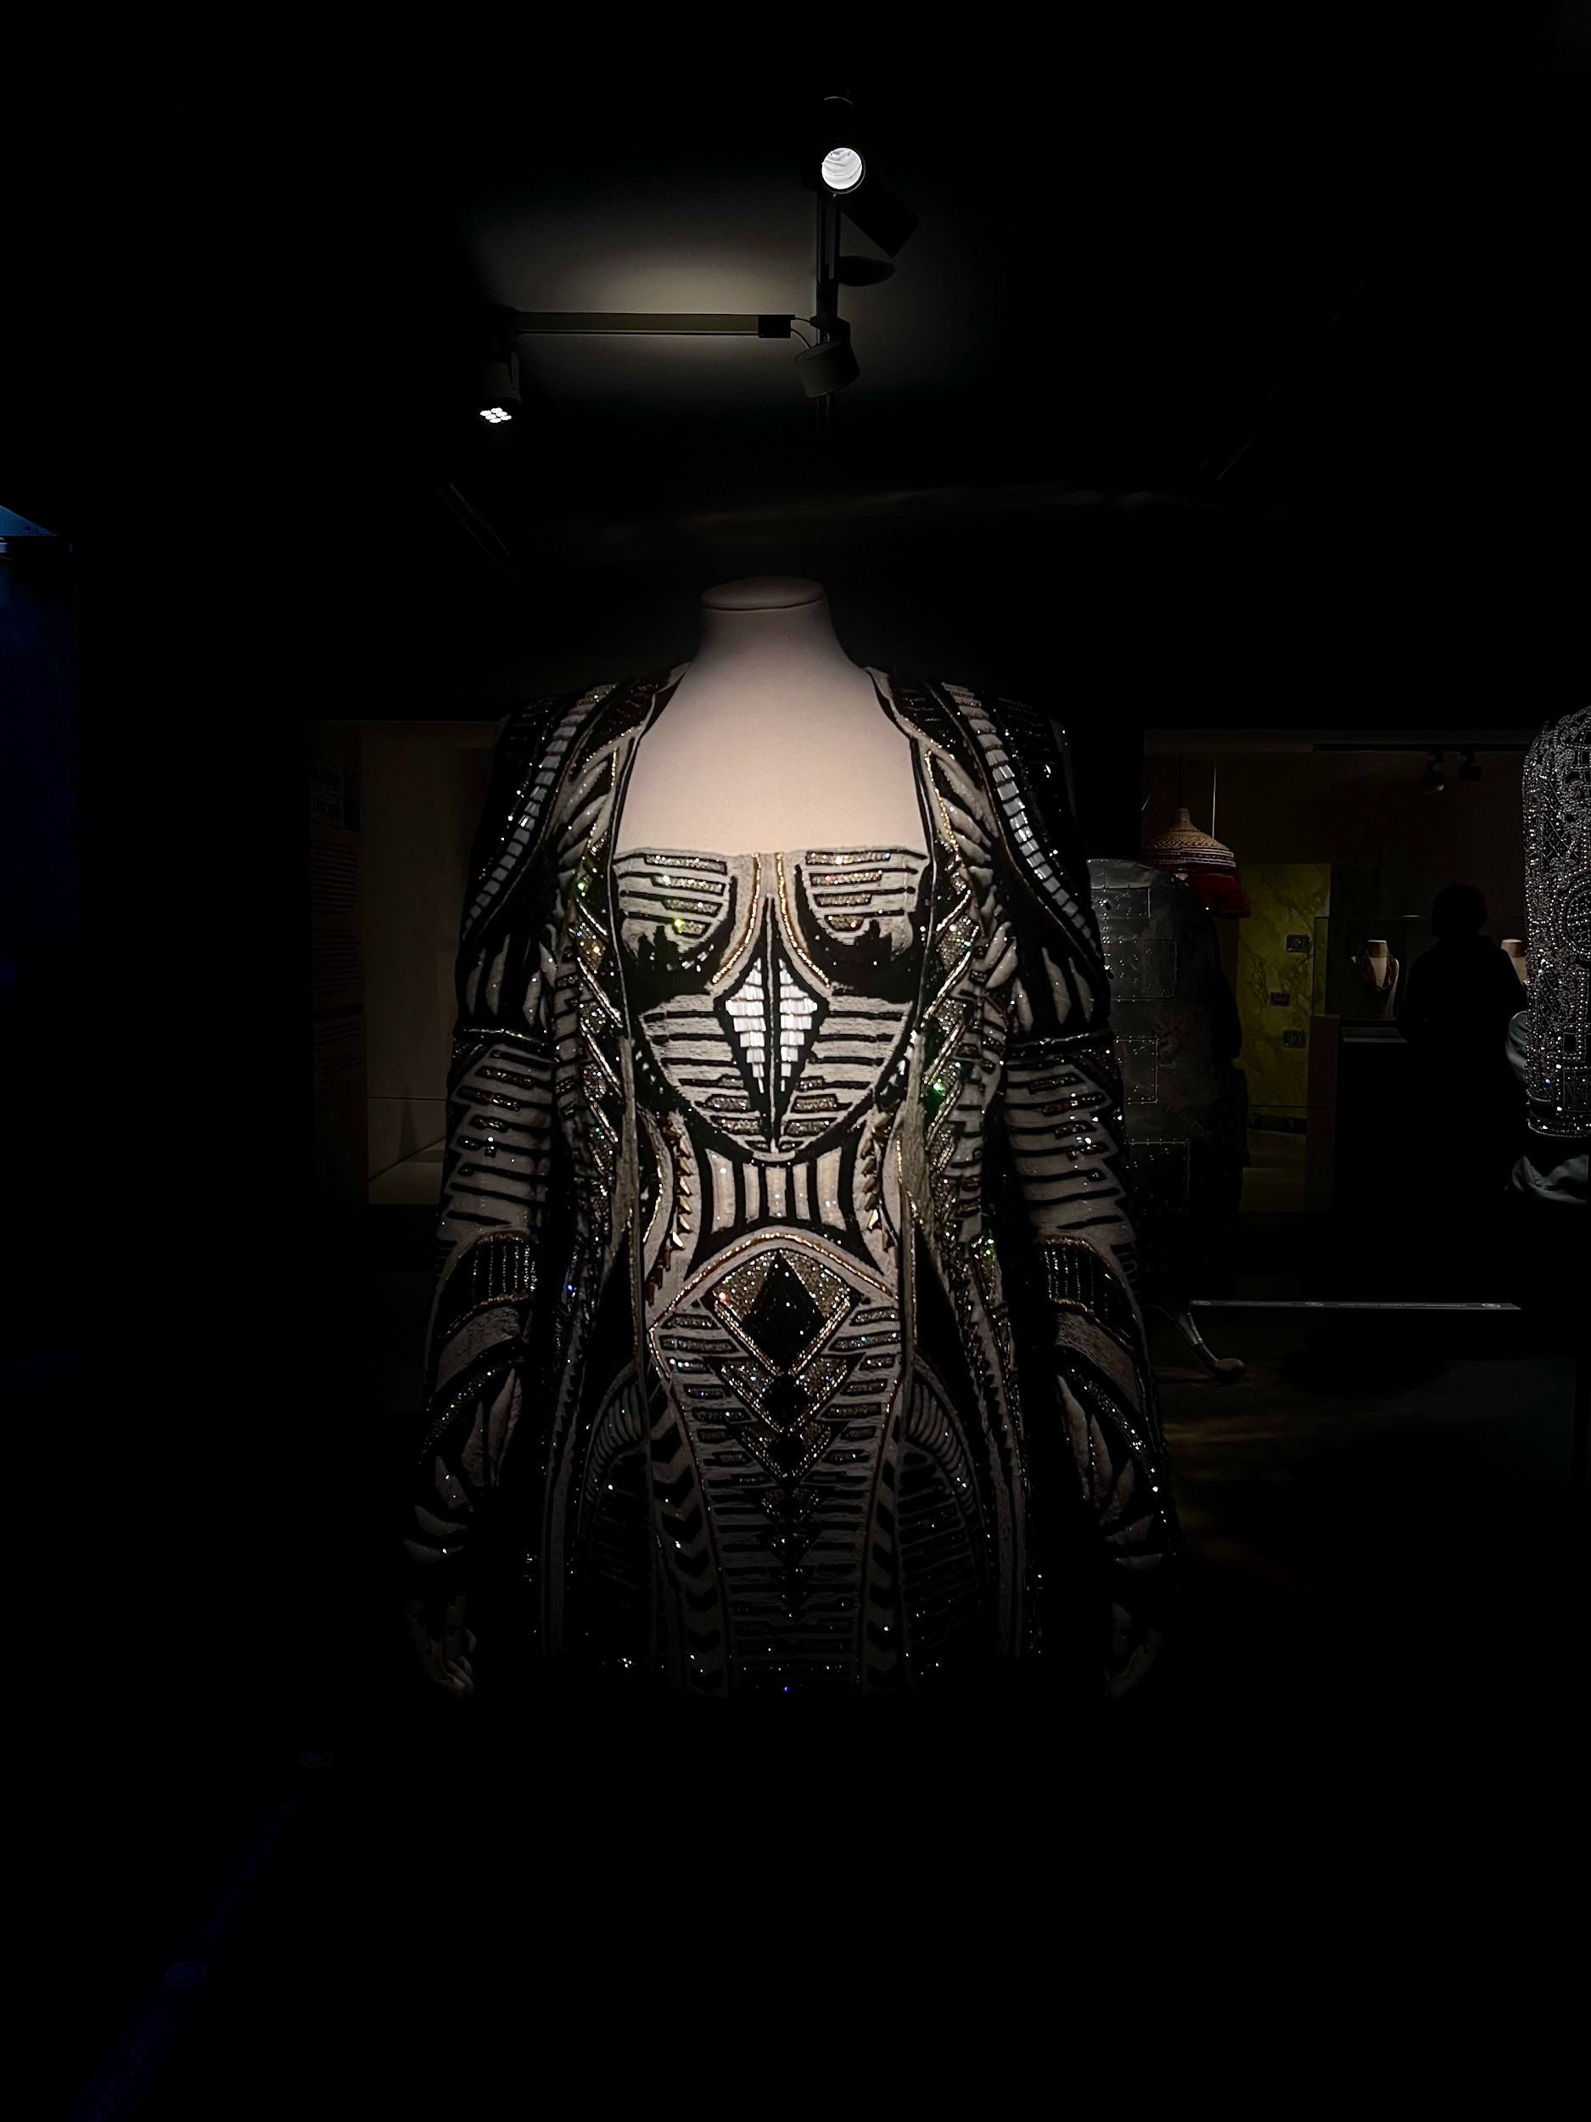
Rooney noted the beautiful embroidery. Albertini had experience with Chanel and Schiaparelli. This attention to detail is proof of the ever-thriving ideals of Haute Couture.

It can be noted that the French public often incorporated various trending styles from around the world. An affinity for Air Jordan 1’s was evident during the Manship Schools time at the olympics.

*This writer found a welcome assumed assimilation due to dawning a sleeveless brown Ultra Light Down puffer jacket. The attendees of Wanderlust nightclub were quite drawn to it*



